sh  shed  splash  flash  shrimp  shell  fishing | ee/e-e/ea  see  been  sleep  three  green  seen  theme  these  complete  clean  dream  seat  scream | Alien words to practise    kib  lan  sheb  yig  jep  zang  blish  stron  sprozz  smath  scrock  spust  menk  thab  quob  zep  ched  zox  hiff  thim  quig  ress  chab  jalp  hong  plong  jeng  butong  zink  shronk  chay  vray  steen  fleep  cheeth  kigh  pright  sprow  trow  moom  drood  sploot  charp  wule  trute  vite  toke  blone  flide  plarp  nart  forg  skorb  morch  sporg  jair  zair  plair  wirp  quirp  nirth  doud  frout  yound  bloy  skpy  stoy  theat  heab  reet  coink  plake  quade  zaw  traw  jare  slare  hurn  purf  gownt  zown  oad  snew  chure  vure  frue  snue  feme  gede  knoon  whum  whep
th  third  fifth  think  thunder  thin  thank | ie/igh/i-e  high  light  bright  night  might  fright  smile  time  hide  white  pie  lie  tried
ch  chill  bench  chips  crunch  charm  chat | ow/o-e/oa  blow  snow  know  show  low  slow  home  broke  phone  note  goat  boat  toast  throat
qu  queen  squash  quick  quack | oo/u-e/ew  too  food  moon  zoo  pool  spoon  tune  use  huge  brute  drew  grew  flew
ng  thing  sting  fang  sing  flashing  swing | oo  took  book  shook  look  foot  cook
ay/ai/a-e  play  day  may  spray  say  chain  rain  stain  make  cake  late | ar  car  star  part  hard  sharp
or/aw/au  sort  horse  shot  sport  snort  saw  crawl  yawn  paw  pause  author | air/are  fair  hair  chair  stair  air  lair  share  square  bare  dare
ir/ur/er  girl  third  twirl  bird  whirl  dirt  nurse  burn  turn  purse  proper  after  corner  never | ou/ow  out  loud  round  found  mouth  shout  cow  brown  down  now
oy/oi  toy  enjoy  boy  joyful  join  voice  coin | ph  phone  orphan  nephew  elephant
ire  fire  wire  bonfire  conspire | ear  dear  near  fear  year
ure  pure  sure  adventure  mixture  picture | ue  blue  glue  due  rescue
kn  knock  knight  knee  knit | wh  whisk  whirl  white  whisper

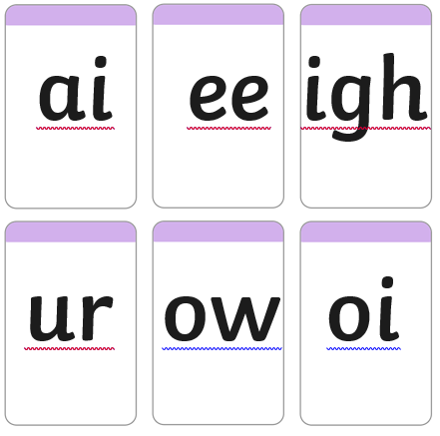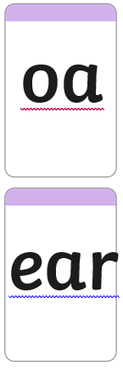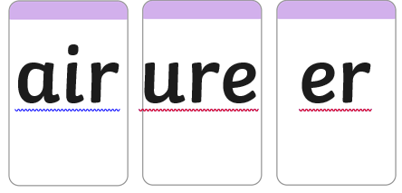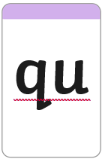
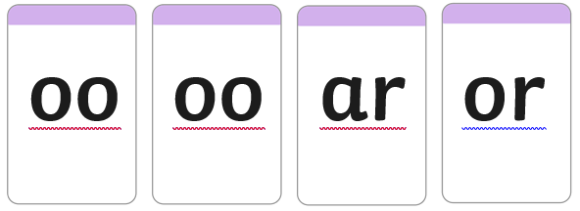
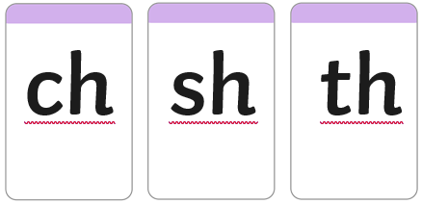
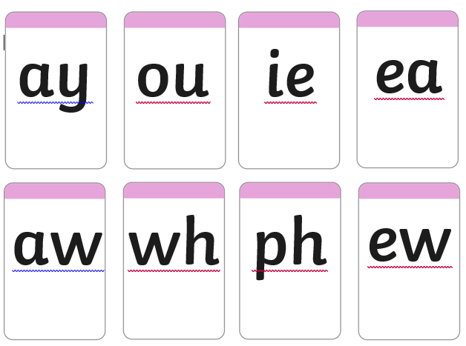
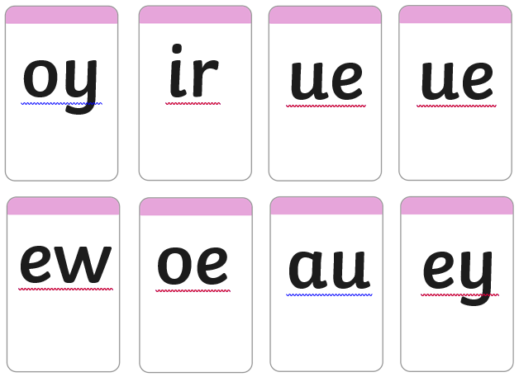
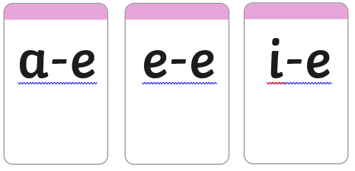
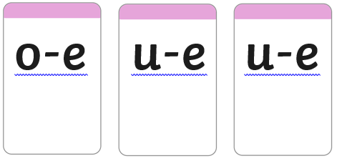

Phonics Revision Pack 2026
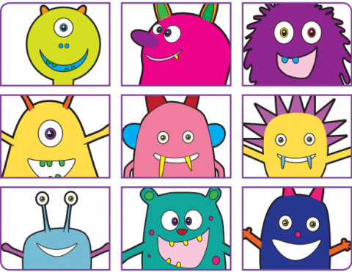
This year the Phonics Screening Test will be held W/B 8th June 2026. This is a revision pack to help your child consolidate and practise all the sounds we have learnt so far.
In the pack there are some sound cards. These can be cut up and used as flash cards to practise. For each sound, there are some real and some ‘alien’ (nonsense) words to practise reading. Encourage your child to spot the digraphs and trigraphs (sounds with more than 1 letter) and to sound out the words to read.
You can find more practice materials here
https://www.gov.uk/government/publications/phonics-screening-check-2022-materials

We have been learning and practising phonics everyday all year in school and will continue to do so.
For your information, in a recent practise check, your child scored

Given this, and the help they receive at home, they are likely to pass the check in June.

Given this, without regular practise at home, they are unlikely to pass the check in June.

