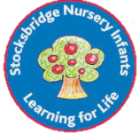
Stocksbridge NI School
Long Term Plan Cycle B 2025-2026
 | Summer 1 |  | Summer 2
Theme | Extreme Environments |  | Seasides
Sensational Start  Fabulous Finish | Explorer visiting- James Ketchell |  | A visit to the seaside- Bridlington
SMSC and values
Online safety   | YEAR 1  Online Safety  https://projectevolve.co.uk/toolkit/resources/strand/privacy-and-security/early-years-7/  - Year 1: Add Online Relationships - discuss communicating kindly online https://projectevolve.co.uk/toolkit/resources/strand/online-relationships/early-years-7/  YEAR 2  Relationships  Online safety  https://projectevolve.co.uk/toolkit/resources/strand/privacy-and-security/early-years-7/  - Year 2: Add Online Relationships - discuss differences between online and offline friendships  https://projectevolve.co.uk/toolkit/resources/strand/online-relationships/early-years-7/ |  | YEAR 1  Online safety  https://projectevolve.co.uk/toolkit/resources/strand/privacy-and-security/early-years-7/  - Year 1: Add Self Image and Identity - link body image to reputable online sources  https://projectevolve.co.uk/toolkit/resources/strand/self-image-and-identity/early-years-7/  YEAR 2  Online Safety https://projectevolve.co.uk/toolkit/resources/strand/privacy-and-security/early-years-7/  -Year 2: Add Privacy and Security - introduce idea of protecting private information online  https://projectevolve.co.uk/toolkit/resources/strand/self-image-and-identity/early-years-7/
Being a Mathematician   | Y1  Number: Multiplication & Division (Including multiples of 2,5,& 10)  Number: Fractions  Geometry: Position & Direction |  | Y1  Number: Place Value (within 100)  Measurement: Money  Measurement: Time
 | Y2  Number: Fractions  Measurement: Time |  | Y2  Statistics  Geometry: Position & Direction  Problem solving & efficient strategies
Being a Writer and a Reader   | Narrative- children adapt a story  Y1  Use patterns and language from familiar stories in own writing; write complete stories with a simple structure: beginning – middle – end, decide where it is set and use ideas from reading for some incidents and events.  Y2  Imitate familiar stories by borrowing and adapting structures; write complete stories with a sustained, logical sequence of events; use past tense and 1st person consistently; include setting; create characters, e.g. by adapting ideas about typical story characters; include some dialogue; use phrases drawn from story language to add interest, (e.g.) she couldn’t believe her eyes. |  | Persuasion  Y1  Read captions, pictures, posters and adverts that are trying to persuade. Begin to recognise what they are trying to do and some of the ways they do it.  Through games and role play begin to explore what it means to persuade or be persuaded, and what different methods might be effective.  Y2  As part of a wide range of reading, explore simple persuasive texts (posters, adverts, etc.) and begin to understand what they are doing and how.  Evaluate simple persuasive devices (e.g.) Say which posters in a shop or TV adverts would make them want to buy something, and why)  Create simple signs posters and adverts (involving words and/or other modes of communication) to persuade others to do, think or buy something.  Continue to explore persuading and being persuaded in a variety of real life situations through role-play and drama  Poetry  Y1 Seaside acrostic poems  Y2 Sand by Meish Goldish  The Sea Poem by James Reeves
 | Year 1 | Year 2 | Year 1 |  | Year 2
Grammar | Writing in past tense Coordination using ‘and’.  Suffixes er, est | Expanded noun phrases subordinating (when, if)/coordinating (and, so, but)  Adverbs-  suffix ly, ful | Capital letters for proper nouns.  Prefix un  Use question marks and exclamation marks |  | Expanded noun phrases subordinating (when, if)/coordinating (and, so, but)  suffixes - ment, ness & less.  Sentence form – commands  Apostrophes for the possessive. Apostrophes for contracted form
Handwriting | Numerals and capital letters. | Order to teach joins.  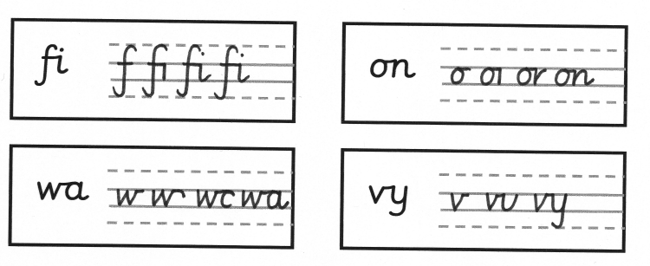  Use the joins within words. | Capital letters.  Revision of errors.  (Expectation that all upper and lower case letters & numerals are formed correctly by the end of Y1) |  | Order to teach joins.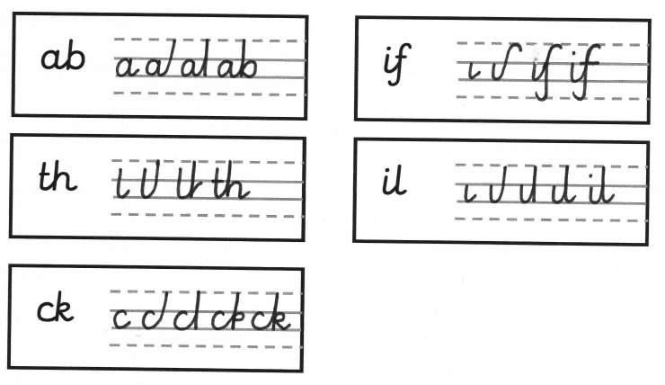  Use the joins within words.
Spellings | In line with monsterphonics HFW spellings  Recap of 100 words that were taught in Autumn | In line with monsterphonics  Recap of CEW and spelling rules | In line with monsterphonics HFW spellings  Recap of 100 words that were taught in Autumn |  | In line with monsterphonics  Recap of CEW and spelling rules
Being a Scientist   | Animals including humans  find out about and describe the basic needs of animals, including humans, for survival (water, food and air)  Living things and their habitats  identify that most living things live in habitats to which they are suited and describe how different habitats provide for the basic needs of different kinds of animals and plants, and how they depend on each other  Aim: to learn about extreme environments and how animals and people have adapted. |  | Use of everyday materials (Year 2)  Pupils should be taught to:  identify and compare the suitability of a variety of everyday materials, including wood, metal, plastic, glass, brick, rock, paper and cardboard for particular uses  Everyday materials (Year 1)  Pupils should be taught to:  -describe the simple physical properties of a variety of everyday materials  - compare and group together a variety of everyday materials on the basis of their simple physical properties.  Aim: Investigate, which material makes the best lenses for sunglasses and why  Seasonal changes- local environment throughout the year to explore and answer questions about plants growing in a habitat
Being a Historian   | Not this half term |  | Pupils should be taught about:  - changes within living memory.  - the lives of significant individuals in the past who have contributed to national and international achievements- Grace Darling  Aim: To know how seaside visits have changed over time.  To know the part that Grace Darling played in the rescue of survivors from a wrecked merchant ship in 1838
Being a Geographer   | Locational knowledge  name and locate the world’s seven continents and five oceans  Human and physical geography  Identify seasonal and daily weather patterns in the United Kingdom and the location of hot and cold areas of the world in relation to the Equator and the North and South Poles.  Geographical skills and fieldwork  use aerial photographs and plan perspectives to recognise landmarks and basic human and physical features  Aim: To know human and physical features of hot and cold areas of the world, naming and identifying them on a map. |  | Human and physical geography  Use basic geographical vocabulary to refer to physical and human features- beach, cliff, coast, sea, ocean, harbour, port, shop, lighthouse  Use fieldwork to observe, measure and record the human and physical features in Bridlington using a range of methods, including sketch maps. Compare to Stocksbridge features that we looked at in a previous topic.  Ongoing: use simple compass directions (North, South, East and West). Name the 4 countries of the United Kingdom.  Aim: To use fieldwork skills to talk about the physical and human features of a coastal town (Bridlington) and use these to devise a map with a key.
Being a Computer User   | Year 1  Year 1 – Creating media – Digital writing  Learners will develop their understanding of the various aspects of using a computer to create and manipulate text. They will become more familiar with using a keyboard and mouse to enter and remove text. Learners will also consider how to change the look of their text, and will be able to justify their reasoning in making these changes. Finally, learners will consider the differences between using a computer to create text, and writing text on paper. They will be able to explain which method they prefer and explain their reasoning for choosing this.  Year 2  SSoW Unit 4.2 Extending Bee-Bot Programs  In this series of lessons pupils will extend their knowledge of programming floor robots, e.g. Bee-Bots and create more complex programs to draw numbers and create a robot dance. They will learn more about algorithms and programs, and use logical thinking to plan out algorithms to solve given problems. |  | Year 1  KS1 Unit 4A - Simple Programs: Bee-Bot LO: Explain that an algorithm is a sequence of instructions that a human or computer can follow to complete a task. Create and debug programs for floor robots, planning out an algorithm first.  Year 2  Year 2 – Programming quizzes  This unit initially recaps on learning from the Year 1 ScratchJr unit ‘Programming B – Programming animations’. Learners begin to understand that sequences of commands have an outcome, and make predictions based on their learning. They use and modify designs to create their own quiz questions in ScratchJr, and realise these designs in ScratchJr using blocks of code. Finally, learners evaluate their work and make improvements to their programming projects.
Being a Designer   | Textiles  Design  generate, develop, model and communicate their ideas through talking, drawing, templates, mock-ups and, where appropriate, information and communication technology  Make  Select from and use a wide range of materials and components, including textiles  Evaluate  Evaluate their ideas and products against design criteria  Aim: To develop weaving skills using fabric and a loom
Being a Musician   | Musical Activities – learn a wide range of songs and perform them.  To use ‘higher’ or ‘lower’ to describe sounds  To pitch-match simple phrases  To explore vocal timbre  To use graphic notation to represent pitch  To play ascending and descending melodies on tuned percussion  To sing pentatonic songs. To begin to recognize pentatonic scales. |  | Musical Activities – learn a wide range of songs and perform them.  To compose simple pentatonic melodies  To play and sing melodies that move up and down by step  To recognise melodies that move by step or leap  To use graphic notation to represent a melody  To prepare songs for performance  To perform simple instrumental accompaniments
Being an Artist   | Pupils should be taught:  To develop a wide range of art and design techniques in using colour, pattern, texture, line, shape, form and space.  To produce creative work, exploring their ideas and recording  Aim- to create a mixed media collage. |  | Pupils should be taught to  To know about great artists, craft makers and designers, and understand the historical and cultural development of their art forms, whilst making links to their own work.  To develop a wide range of art and design techniques in using colour, pattern, texture, line, shape, form and space.  To produce creative work, exploring their ideas and recording their experiences.  Aim- to create art based around the theme ‘At the seaside.’
Being a Sportsperson   | Indoor PE  https://platform.imoves.com/subjects/3  DANCE  YEAR 1- ANiMALS  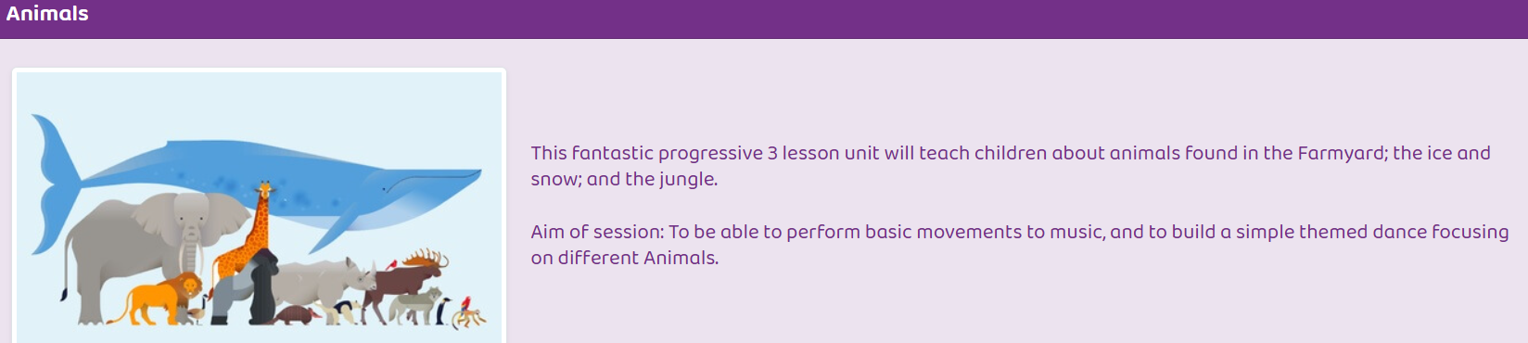  RAINFOREST  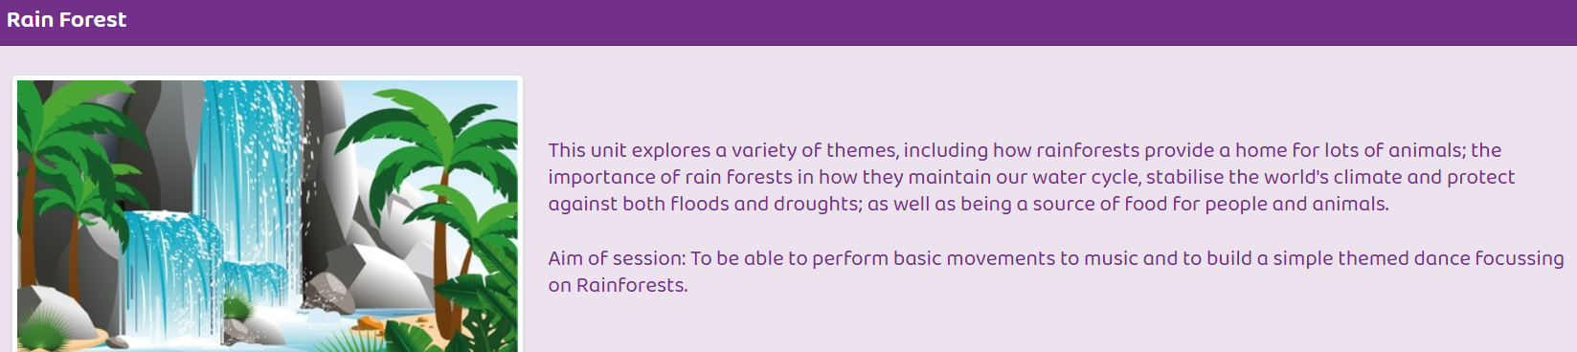  YEAR 2- ANIMALS  . 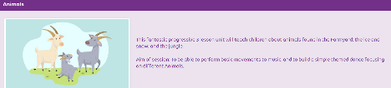  RAINFOREST  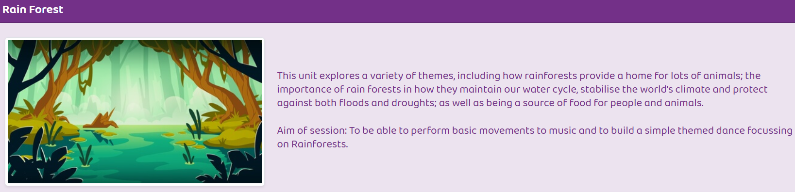  REMEMBER TO CHOOSE CORRECT YEAR GROUP | Outdoor PE GetSet4PE:  STRIKING AND FIELDING GAMES  YEAR 1  Key Skills  Physical: underarm throw, overarm throw, catch, track, bat, balance, jump, run  Social: communication, collaboration, support and encourage others, kindness  Emotional: manage emotions, honesty, perseverance  Thinking: comprehension, use tactics, select and apply, decision making.  YEAR 2  Key Skills  Physical: underarm throw, overarm throw, catch, track, bowl, bat, balance, jump, run  Social: communication, encourage others, collaboration  Emotional: honesty, perseverance, determination, acceptance  Thinking: use tactics, comprehension, select and apply, decision making. | Indoor PE GetSet4PE:  FITNESS AND TARGET GAMES (2 units)  YEAR 1  Key Skills Fitness  Physical: run, jump, co-ordination, stamina, strength, agility, balance, throw  Social: communication, co-operation, support, work safely, kindness  Emotional: kindness, perseverance, honesty, independence, determination  Thinking: comprehension, creativity, problem solving, reflection, feedback  YEAR 2  Key Skills Fitness  Physical: run, stamina, skip, co-ordination, agility, strength, balance, jump  Social: encourage others, communication  Emotional: determination, perseverance  Thinking: comprehension, identify strengths and areas for improvement | Outdoor PE GetSet4PE:  ATHLETICS  YEAR 1  Key Skills  Physical: run, balance, agility, co-ordination, hop, jump, leap, throw  Social: work safely, collaboration  Emotional: perseverance, independence, honesty, determination  Thinking: reflection, comprehension, select and apply skills  YEAR 2  Key Skills  Physical: run, jump for distance, jump for height, throw for distance, throw for accuracy, balance  Social: communication, work safely, support others  Emotional: determination, independence  Thinking: comprehension, observe and provide feedback, explore ideas, select and apply skills
Studying Religions   | https://www.natre.org.uk/member-login/  YEAR 1  Unit 11 What does it mean to belong to a faith community? THEMATIC Christianity Judaism In this unit, the pupils will focus on what it means to belong to a faith community. They will build on their knowledge from Foundation Stage units and revisit knowledge from prior systematic units about ways of life for Christian and Jewish people, considering how members of these communities show that they belong. Unit 3 exploring community and belonging Units 30 which explores how people from different communities mark significant events in life  YEAR 2  Unit 17 Who is a Muslim and how do they live? (part 2) GOD TAWHID IBADAH Islam In this unit, pupils will find out about Islam, key beliefs, and ways of living for many Muslims. Pupils will learn about some of the key Muslim beliefs about God, the teachings of the Prophet, the 5 pillars of Islam and the importance of prayer. The placement of this unit, allows pupils to revise unit 15 and deepen their learning. This is a unit in 2 parts Units 3, 5, 6 and 15 where pupils are introduced to Islam, G-d, Tawhid and Ibadah Units 21 and 32 that develops understanding of Muslim beliefs about God Tawhid and Ibadah |  | https://www.natre.org.uk/member-login/  YEAR 1  Unit 12 How should we care for the world and for others, and why does it matter? THEMATIC Christianity Judaism In this unit, pupils will build on what they know about key texts and practices important to Christian and Jewish people. Pupils will revise their knowledge of Genesis 1 and what this account of creation tells Christian and Jewish people about caring for the world, and think carefully about different ways in which they might care for people in the world. Units 1, 7, 12, 23 and 34, exploring Christian ideas about Creation. Unit 24 that develops understanding how Christians, Jews, Muslims and people with non-religious worldviews how people try to make the world a better place  YEAR 2  Unit 18 What makes some places special to believers?  THEMATIC Christianity Islam Judaism In this unit, pupils will find out about various places of worship and why they are important to many believers. They will build on prior learning about Christians, Muslims and special places. Pupils will focus on the key features of churches, mosques and synagogues how they support their local communities in practical ways. Units 5 exploring special places Units 8, 10, 13, 14, 15, 16, 17 which are systematic studies of Christians and Muslims

