KS1 Writing Overview Updated 2025

English sequence | Narrative-retell a story ORALLY  Y1  Write simple dictated sentences from a familiar story.  Y2  Oral story telling.  Write extended sentences using the conjunction ‘and’ to retell a familiar story. | Recount  Y1  Describe incidents from own experience in an audible voice.  ; listen to other’s recounts and ask relevant questions.  Write simple first person recounts linked to topics of interest/study or to personal experience, using the language of texts read as models for own writing, maintaining consistency in tense and person.  Y2  Describe incidents from own experience in an audible voice using sequencing words and phrases such as ‘then’, ‘after that’;  Listen to other’s recounts and ask relevant questions.  Read personal recounts and begin to recognise generic structure, e.g. ordered sequence of events, use of words like first, next, after, when.  Write simple first person recounts linked to topics of interest/study or to personal experience, using the language of texts read as models for own writing, maintaining consistency in tense and person.  Poetry (repeated in Year A and B)  Y1- Firework poem ‘Zim Zam Zoom’  -perform  Y2- ‘Firework poem’ The Wright Stuff  -perform and write | Narrative- retell a story  Y1  Use patterns and language from familiar stories in own writing.  Write simple character descriptions.  Y2  Imitate familiar stories by borrowing and adapting structures. Explore and write a part of a story with a sustained, logical sequence of events; use past tense and 3rd person consistently; include setting; create characters, e.g. by adapting ideas about typical story characters; include some dialogue; use phrases drawn from story language to add interest, (e.g.) She couldn’t believe her eyes. | Non chronological report  Y1  Find out about a subject by listening and following text as information books are read, watching a video.  Contribute to a discussion on the subject as information is assembled and the teacher writes the information.  Assemble information on a subject in own experience, (e.g.) food, pets.  Write a simple non-chronological report by writing sentences to describe aspects of the subject.  Y2  After a practical activity or undertaking some research in books or the web, take part in a discussion in another curriculum subject, generalising from repeated occurrences or observations. Distinguish between a description of a single member of a group and the group in general e.g. a particular dog and dogs in general. Read texts containing information in a simple report format, e.g. There are two sorts of x...; They live in x...; the As have x..., but the B’s etc.  Assemble information on another subject and use the text as a template for writing a report on it, using appropriate language to present, and categorise ideas  Poetry- YEAR A  Y1 African Animals  https://www.earlylearninghq.org.uk/latest-resources/african-animals-poem/  Y2  Song of the Animal World (traditional African poem)  Scholastic  POETRY YEAR B- Nature themed | Narrative- children adapt a story  Y1  Use patterns and language from familiar stories in own writing; write complete stories with a simple structure: beginning – middle – end, decide where it is set and use ideas from reading for some incidents and events.  Y2  Imitate familiar stories by borrowing and adapting structures; write complete stories with a sustained, logical sequence of events; use past tense and 1st person consistently; include setting; create characters, e.g. by adapting ideas about typical story characters; include some dialogue; use phrases drawn from story language to add interest, (e.g.) she couldn’t believe her eyes. | Persuasion  Y1  Read captions, pictures, posters and adverts that are trying to persuade. Begin to recognise what they are trying to do and some of the ways they do it.  Through games and role play begin to explore what it means to persuade or be persuaded, and what different methods might be effective.  Y2  As part of a wide range of reading, explore simple persuasive texts (posters, adverts, etc.) and begin to understand what they are doing and how.  Evaluate simple persuasive devices (e.g.) Say which posters in a shop or TV adverts would make them want to buy something, and why)  Create simple signs posters and adverts (involving words and/or other modes of communication) to persuade others to do, think or buy something.  Continue to explore persuading and being persuaded in a variety of real life situations through role-play and drama.  Poetry- YEAR A  Y1 Nut tree by Julia Donaldson  What do you do on a nature walk by Kate Williams  Y2 Y2 Mr Magoo’s Amazing Zoo  POETRY YEAR B- seaside themed  Y1 Seaside acrostic poems  Y2 Sand by Meish Goldish  The Sea Poem by James Reeves
Year 1  Grammar | Writing simple sentences with capital letters,  full stops  finger spaces  Nouns and verbs (The dog can run. The frog can hop.) | Capital I for first person pronouns. Adjectives. Noun phrases (The big dog can run. The green frog can hop.) | Present tense. Coordination using ‘and’.  Suffixes ing, ed | Plurals s, es Coordination using ‘and’.  Use question marks and exclamation marks | Writing in past tense Coordination using ‘and’.  Suffixes er, est | Capital letters for proper nouns.  Prefix un  Use question marks and exclamation marks
Year 2  Grammar | Capital letters, full stops, nouns, verbs, adjectives. Use conjunction ‘and’ to extend a sentence  (The green frog is jumping down the  road and is fast.) | Sentence forms - questions and exclamations Subordinating (  because) and coordinating (and, so, but) conjunctions. | Expanded noun phrases,  past tense (ed)  subordinating (that) /coordinating (and, so, but) | Expanded noun phrases subordinating (when, if)/coordinating (and, so, but)  Commas in a list  Use question marks and exclamation marks | Expanded noun phrases subordinating (when, if)/coordinating (and, so, but)  Adverbs-  suffix ly, ful | Expanded noun phrases subordinating (when, if)/coordinating (and, so, but)  suffixes - ment, ness & less.  Sentence form – commands  Apostrophes for the possessive. Apostrophes for contracted form
Year 1  Handwriting | Letter formation check  Order to teach:  L,I,t  t,j,  c,o,a  d,g,q  e – revise d,g  r,n,m  n,m,h  b,k | Order to teach:  p – revise any that need it  v,w  u,y  s,f  x,z  revise and that need it. | Order to teach:  L,I,t  t,j,  c,o,a  d,g,q  e – revise d,g  r,n,m  n,m,h  b,k  include in words. | L,I,t  t,j,  c,o,a  d,g,q  e – revise d,g  r,n,m  n,m,h  b,k  include in words. | Numerals and capital letters. | Capital letters.  Revision of errors.  (Expectation that all upper and lower case letters & numerals are formed correctly by the end of Y1)
Year 2  Handwriting | Letter formation check  Revise  L,I,t  t,j,  c,o,a  d,g,q  e – revise d,g  r,n,m  n,m,h  b,k  include in words. | L,I,t  t,j,  c,o,a  d,g,q  e – revise d,g  r,n,m  n,m,h  b,k  include in words. | Capital letters. | Order to teach joins.  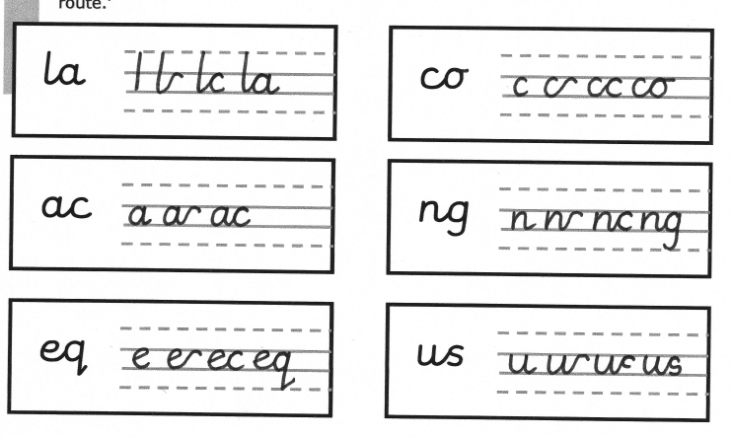  Use the joins within words. | Order to teach joins.  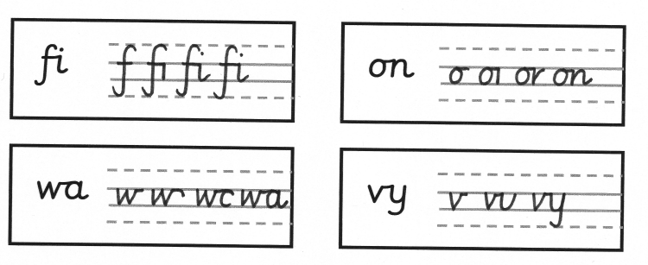  Use the joins within words. | Order to teach joins.  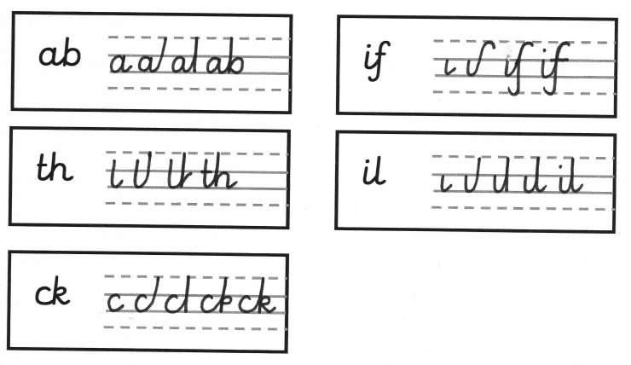  Use the joins within words.
Year One Spelling | In line with monster phonics HFW spellings  First 100 words will be taught in Autumn | In line with monster phonics HFW spellings  First 100 words will be taught in Autumn | In line with monster phonics HFW spellings  Next 200 words will be taught in Spring | In line with monster phonics HFW spellings  Next 200 words will be taught in Spring | In line with monster phonics HFW spellings  Recap of 100 words that were taught in Autumn | In line with monster phonics HFW spellings  Recap of 100 words that were taught in Autumn
Year Two Spelling | In line with monster phonics  CEW for Year 2 spellings in Autumn Spelling rules, including the rules for adding vowel suffixes: the drop e, double consonant and y to an i rule | In line with monster phonics  CEW for Year 2 spellings in Autumn  Spelling rules, including the rules for adding vowel suffixes: the drop e, double consonant and y to an i rule | In line with monster phonics  spelling rules with a focus on consonant suffixes, contractions and possessive apostrophes. | In line with monster phonics  spelling rules with a focus on consonant suffixes, contractions and possessive apostrophes. | In line with monster phonics  Recap of CEW and spelling rules | In line with monster phonics  Recap of CEW and spelling rules
Year One  Focus words for reading | Today, love, once, friend, your, here, there, school, house, where, were, they, says, animals, very, when, out, | saw, all, down, now, what, called, horse, gone, live, would, | Please, mouse, he’s, we’re, even, began,before, because, really, these, other, mother, another, floppy, any, many, every, everyone, baby, only, suddenly | Want, great, can’t key, white, fly, why, use, there, couldn’t, eyes, llaughed, different, door, thought, through, magic, narrator, air, who, I’ve, I’ll, these | Recap of all previous words | Recap of all previous words
Year Two  Focus words for reading | Should, floor, poor, pretty, move, prove, improve, every, everybody, even, whole, clothes, busy, money, Christmas | Father, half, sure, sugar, water, parents, beautiful, who | Recap of all previous words | Recap of all previous words | Recap of all previous words | Recap of all previous words

