 |  | Autumn 1 | Autumn 2 | Spring 1 | Spring 2 | Summer 1 | Summer 2
Theme title |  | Me and My School in Stocksbridge | Hidden Heroes | Healthy Me | Nurturing Nature | Extreme Environments | How I do like to be beside the seaside
Theme led by…. |  | History, Geog, science | History and DT  Mechanisms | DT-food  PSHE  PE  Active travel week | Science, art | Geog, science,DT | History, Geog,DT (boat)
Substantive Concepts (knowledge)  Disciplinary concepts (skills) |  | Community  Leaders | Community  Leaders |  |  |  | Community
SPARKLING STARTER… THE  PROVOCATION |  | Local walk | Visits from Fire service, Paramedic, community police at points in the half term |  |  | James Ketchell explorer | Visit to the Seaside
Maths Y1 |  | Number: Place Value(Within 10)  Number: Addition & Subtraction (Within 10) | Number: Addition & Subtraction (Within 10)  Geometry: Shape | Number: Place Value  (Within 20)  Number: Addition & Subtraction (Within 20) | Number: Place Value  (Within 50)  Measurement: Length & Height  Measurement: Mass & Volume | Number: Multiplication & Division (Including multiples of 2,5,& 10)  Number: Fractions  Geometry: Position & Direction | Number: Place Value (within 100)  Measurement: Money  Measurement: Time
Maths Y2 |  | Number: Place Value (within 100)  Number: Addition & Subtraction | Number: Addition & Subtraction  Geometry: Shape | Measurement: Money  Number: Multiplication & Division | Number: Multiplication & Division  Measurement: Length & Height  Measurement: Mass, Capacity and Temperature | Number: Fractions  Measurement: Time | Statistics  Geometry: Position & Direction  Problem solving & efficient strategies
English including book focus |  | Narrative-retell a story ORALLY  Y1  Write simple dictated sentences from a familiar story.  Y2  Oral story telling.  Write extended sentences using the conjunction ‘and’ to retell a familiar story. | Poetry  Y1- Firework poem ‘Zim Zam Zoom’  Y2- ‘Firework poem’ The Wright Stuff  Recount  Y1  Describe incidents from own experience in an audible voice using sequencing words and phrases such as ‘then’, ‘after that’ first, next, after, when.  ; listen to other’s recounts and ask relevant questions.  Write simple first person recounts linked to topics of interest/study or to personal experience, using the language of texts read as models for own writing, maintaining consistency in tense and person.  Y2  Describe incidents from own experience in an audible voice using sequencing words and phrases such as ‘then’, ‘after that’; listen to other’s recounts and ask relevant questions.  Read personal recounts and begin to recognise generic structure, e.g. ordered sequence of events, use of words like first, next, after, when.  Write simple first person recounts linked to topics of interest/study or to personal experience, using the language of texts read as models for own writing, maintaining consistency in tense and person. | Narrative- retell a story, create a resolution and ending  Y1  Use patterns and language from familiar stories in own writing; write complete stories with a simple structure: beginning – middle – end, decide where it is set and use ideas from reading for some incidents and events.  Y2  Imitate familiar stories by borrowing and adapting structures; write complete stories with a sustained, logical sequence of events; use past tense and 3rd person consistently; include setting; create characters, e.g. by adapting ideas about typical story characters; include some dialogue; use phrases drawn from story language to add interest, (e.g.) She couldn’t believe her eyes. | Non chronological report  Y1  Find out about a subject by listening and following text as information books are read, watching a video.  Contribute to a discussion on the subject as information is assembled and the teacher writes the information.  Assemble information on a subject in own experience, (e.g.) food, pets.  Write a simple non-chronological report by writing sentences to describe aspects of the subject.  Y2  After a practical activity or undertaking some research in books or the web, take part in a discussion in another curriculum subject, generalising from repeated occurrences or observations. Distinguish between a description of a single member of a group and the group in general e.g. a particular dog and dogs in general. Read texts containing information in a simple report format, e.g. There are two sorts of x...; They live in x...; the As have x..., but the B’s etc.  Assemble information on another subject and use the text as a template for writing a report on it, using appropriate language to present, and categorise ideas  Poetry  Y1 Nut tree by Julia Donaldson  What do you do on a nature walk by Kate Williams (repeated Summer 2 Year B  Y2 Mr Magoo’s Amazing Zoo | Narrative- children create own stories  Y1  Use patterns and language from familiar stories in own writing; write complete stories with a simple structure: beginning – middle – end, decide where it is set and use ideas from reading for some incidents and events.  Y2  Imitate familiar stories by borrowing and adapting structures; write complete stories with a sustained, logical sequence of events; use past tense and 3rd person consistently; include setting; create characters, e.g. by adapting ideas about typical story characters; include some dialogue; use phrases drawn from story language to add interest, (e.g.) she couldn’t believe her eyes. | Persuasion  Y1  Read captions, pictures, posters and adverts that are trying to persuade. Begin to recognise what they are trying to do and some of the ways they do it.  Through games and role play begin to explore what it means to persuade or be persuaded, and what different methods might be effective.  Y2  As part of a wide range of reading, explore simple persuasive texts (posters, adverts, etc.) and begin to understand what they are doing and how.  Evaluate simple persuasive devices (e.g.) Say which posters in a shop or TV adverts would make them want to buy something, and why)  Create simple signs posters and adverts (involving words and/or other modes of communication) to persuade others to do, think or buy something.  Continue to explore persuading and being persuaded in a variety of real life situations through role-play and drama.  Poetry  Y1 Seaside acrostic poems  Y2 Sand by Meish Goldish  The Sea Poem by James Reeves
Year 1  Shared Reading Texts |  | 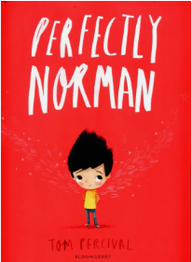  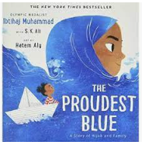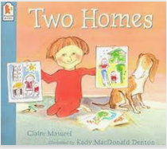  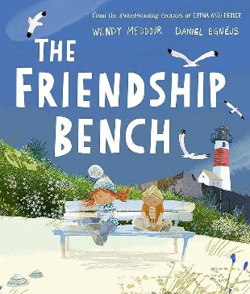 | 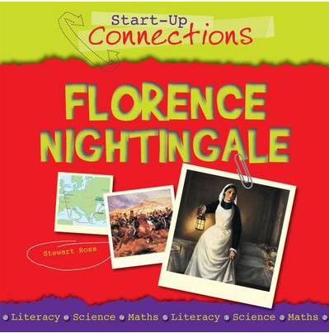  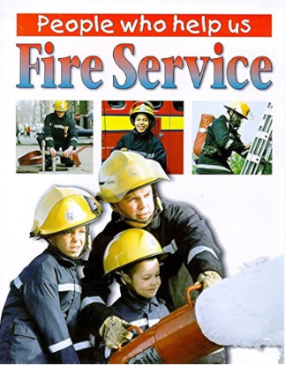  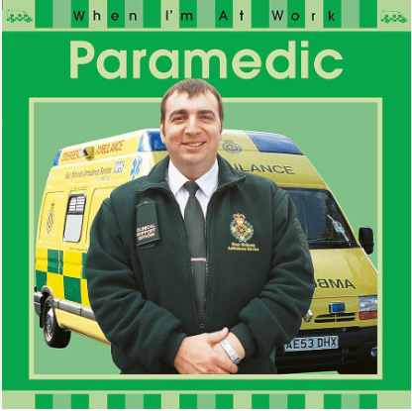  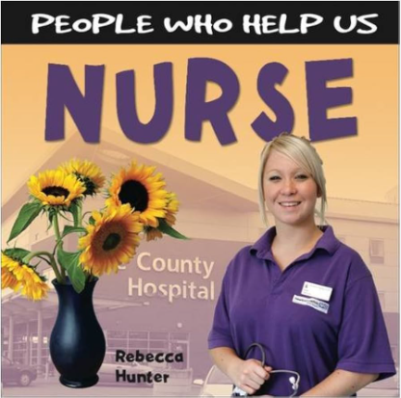 | 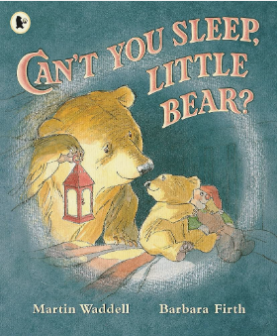  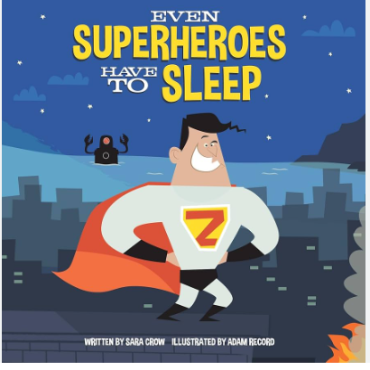  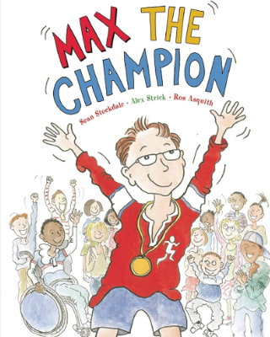  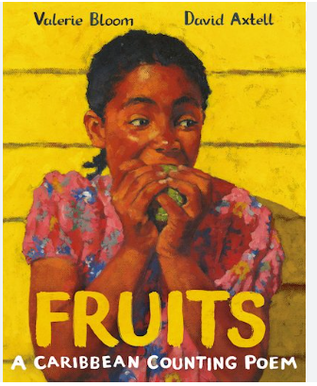 | 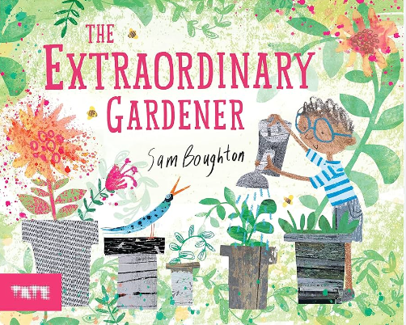  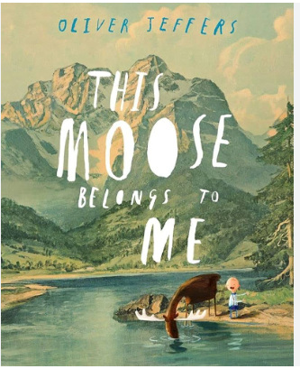  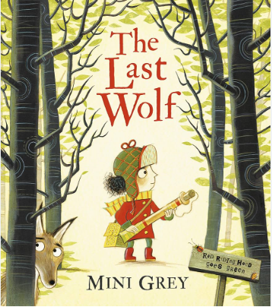  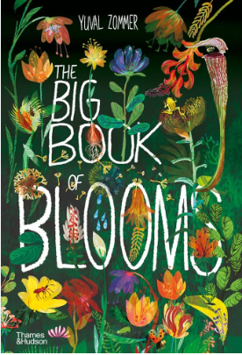 | 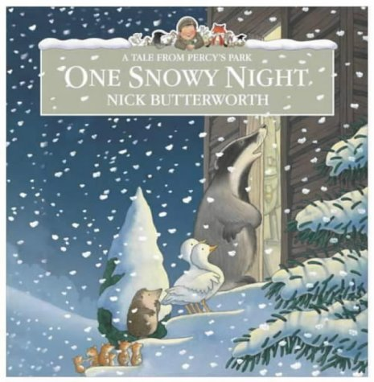  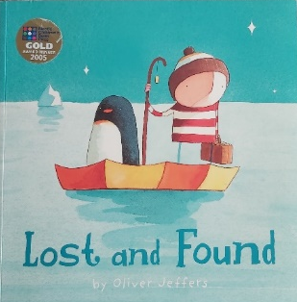  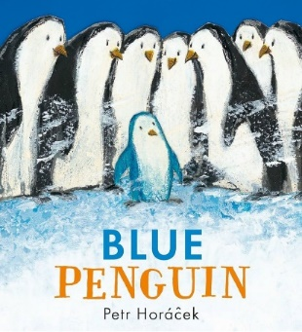  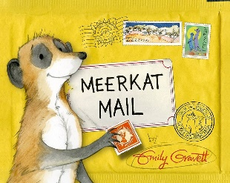  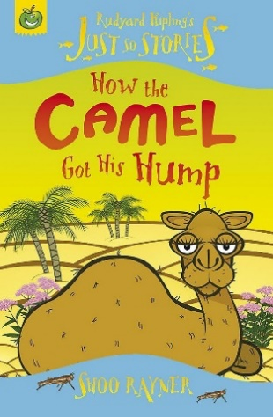
Year 2  Shared Reading Texts |  | 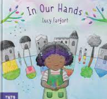  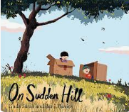  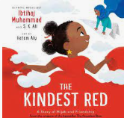  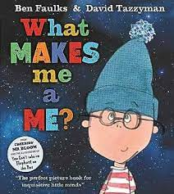 | 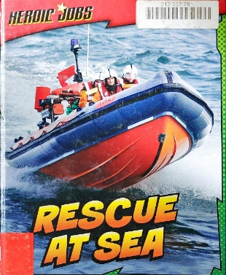  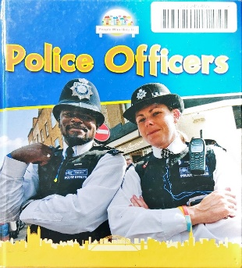  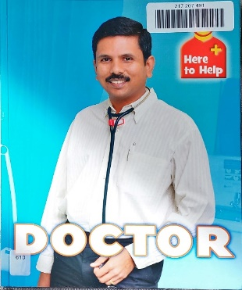  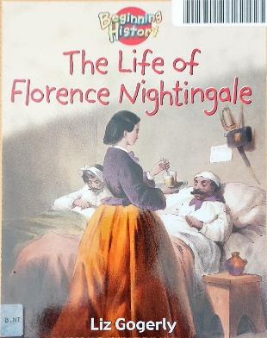  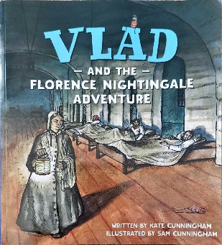 | 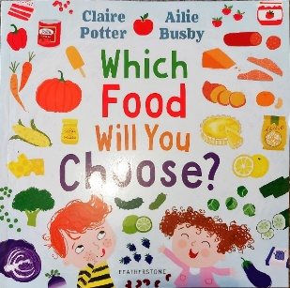  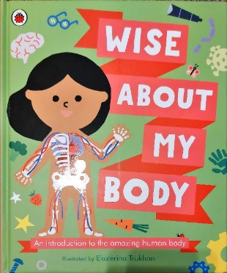  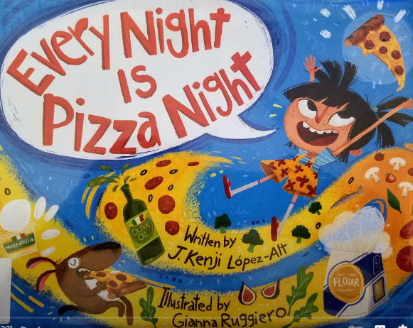  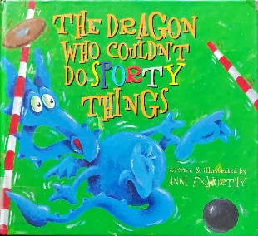  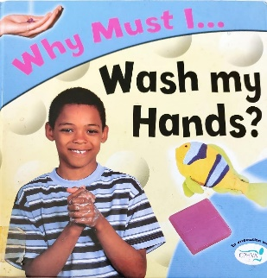 | 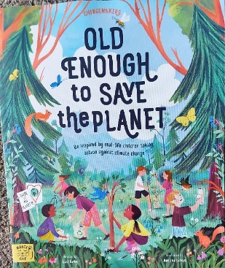  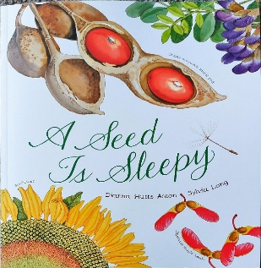  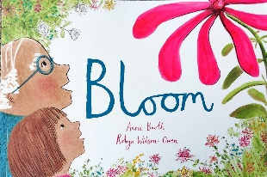  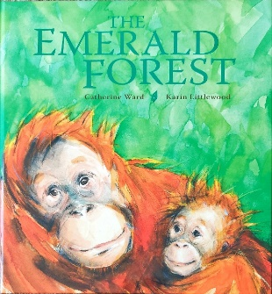 | 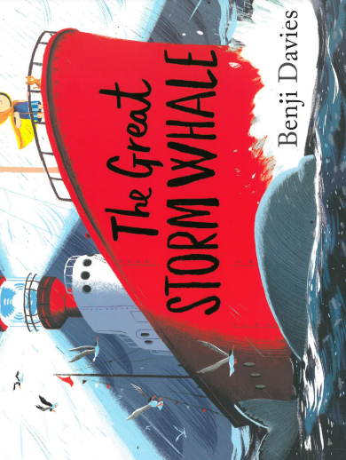  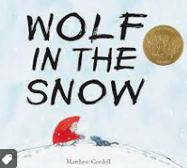  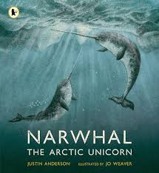  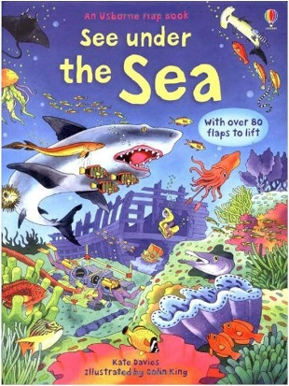  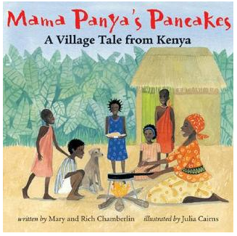  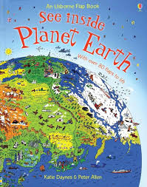
Year 1  Grammar |  | Writing simple sentences with capital letters,  full stops  finger spaces  Nouns and verbs (The dog can run. The frog can hop.) | Capital I for first person pronouns. Adjectives. Noun phrases (The big dog can run. The green frog can hop.) | Present tense. Coordination using ‘and’.  Suffixes ing, ed | Plurals s, es Coordination using ‘but’. | Writing in past tense Coordination using ‘so’.  Suffixes er, est | Capital letters for proper nouns.  Prefix un
Year 2  Grammar |  | Capital letters, full stops, nouns, verbs, adjectives.  (The green frog is jumping down the  road.) | Sentence forms - questions and exclamations Subordinating (  because) and coordinating (and, so, but) conjunctions. | Expanded noun phrases,  past tense (ed)  subordinating (that) /coordinating (and, so, but)  Commas in a list | Expanded noun phrases subordinating (when, if)/coordinating (and, so, but)  Apostrophes for contracted form | Expanded noun phrases subordinating (when, if)/coordinating (and, so, but)  Adverbs-  suffix ly, ful | Expanded noun phrases subordinating (when, if)/coordinating (and, so, but)  Speech marks Prefixes - ment, ness & less.  Sentence form – commands  Apostrophes for the possessive.
Year 1  Handwriting |  | Letter formation check  Order to teach:  L,I,t  t,j,  c,o,a  d,g,q  e – revise d,g  r,n,m  n,m,h  b,k | Order to teach:  p – revise any that need it  v,w  u,y  s,f  x,z  revise and that need it. | Order to teach:  L,I,t  t,j,  c,o,a  d,g,q  e – revise d,g  r,n,m  n,m,h  b,k  include in words. | L,I,t  t,j,  c,o,a  d,g,q  e – revise d,g  r,n,m  n,m,h  b,k  include in words. | Numerals and capital letters. | Capital letters.  Revision of errors.  (Expectation that all upper and lower case letters & numerals are formed correctly by the end of Y1)
Year 2  Handwriting |  | Letter formation check  Revise  L,I,t  t,j,  c,o,a  d,g,q  e – revise d,g  r,n,m  n,m,h  b,k  include in words. | L,I,t  t,j,  c,o,a  d,g,q  e – revise d,g  r,n,m  n,m,h  b,k  include in words. | Capital letters. | Order to teach joins.  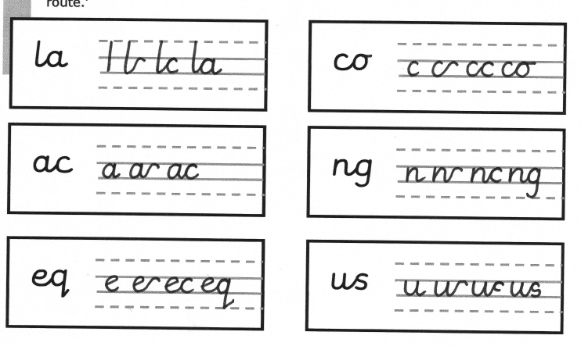  Use the joins within words. | Order to teach joins.  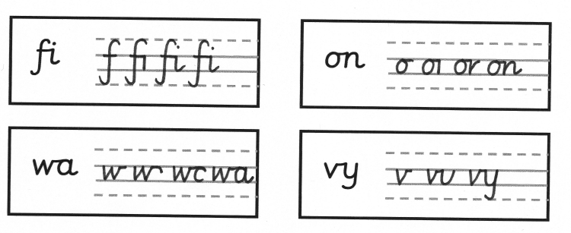  Use the joins within words. | Order to teach joins.  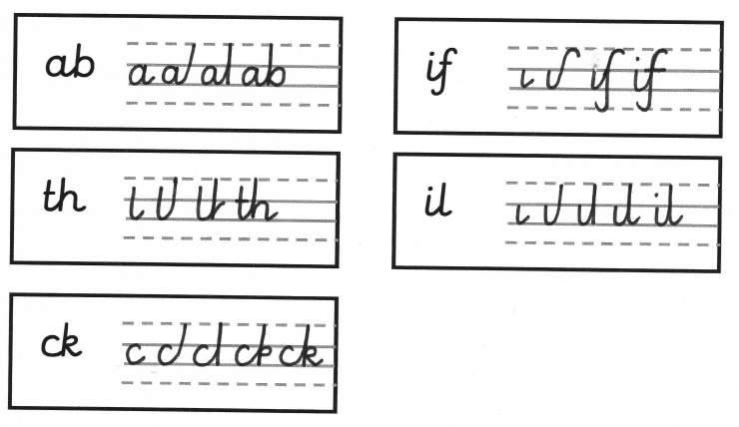  Use the joins within words.
Year One  Spelling |  | In line with monsterphonics HFW spellings  First 100 words will be taught in Autumn | In line with monsterphonics HFW spellings  First 100 words will be taught in Autumn | In line with monsterphonics HFW spellings  Next 200 words will be taught in Spring | In line with monsterphonics HFW spellings  Next 200 words will be taught in Spring | In line with monsterphonics HFW spellings  Recap of 100 words that were taught in Autumn | In line with monsterphonics HFW spellings  Recap of 100 words that were taught in Autumn
Year Two  Spelling |  | In line with monsterphonics  CEW for Year 2 spellings in Autumn Spelling rules, including the rules for adding vowel suffixes: the drop e, double consonant and y to an i rule | In line with monsterphonics  CEW for Year 2 spellings in Autumn  Spelling rules, including the rules for adding vowel suffixes: the drop e, double consonant and y to an i rule | In line with monsterphonics  spelling rules with a focus on consonant suffixes, contractions and possessive apostrophes. | In line with monsterphonics  spelling rules with a focus on consonant suffixes, contractions and possessive apostrophes. | In line with monsterphonics  Recap of CEW and spelling rules | In line with monsterphonics  Recap of CEW and spelling rules
Science |  | Humans and senses- identify and label parts of the body  Pets- describe and compare a structure of a variety of common animals | Material and properties  Seasonal changes- local environment throughout the year to explore and answer questions about plants growing in a habitat | Notice animals including humans have offspring that grow into adults  Importance of exercise for humans  How to stay healthy – sleep, nutrition, exercise, sleep, teeth cleaning, living conditions | Plants- identify and name common and wild plants  Plants in thir habitats  Basic structure of flowering plants  Seasonal changes- local environment throughout the year to explore and answer questions about plants growing in a habitat | Living things and their habitats  Animals- find out and describe the basic needs of animals for survival - adaptation | Material and properties  Seasonal changes- local environment throughout the year to explore and answer questions about plants growing in a habitat
Computing  YEAR 1  YEAR 2 |  | TCC Y1 – Technology around us (key skills).  Learners will develop their understanding of technology and how it can help them in their everyday lives. They will start to become familiar with the different components of a computer by developing their keyboard and mouse skills. Learners will also consider how to use technology responsibly. | TCC Y1 – Creating media: Digital painting.  Learners will develop their understanding of a range of tools used for digital painting. They then use these tools to create their own digital paintings, while gaining inspiration from a range of artists’ work. The unit concludes with learners considering their preferences when painting with and without the use of digital devices. | TCC Y1 – Creating media: Digital writing.  Learners will develop their understanding of the various aspects of using a computer to create and manipulate text. They will become more familiar with using a keyboard and mouse to enter and remove text. Learners will also consider how to change the look of their text, and will be able to justify their reasoning in making these changes. Finally, learners will consider the differences between using a computer to create text, and writing text on paper. They will be able to explain which method they prefer and explain their reasoning for choosing this. | TCC Y1 – Grouping data  This unit introduces learners to data and information. Labelling, grouping, and searching are important aspects of data and information. Searching is a common operation in many applications, and requires an understanding that to search data, it must have labels. This unit of work focuses on assigning data (images) with different labels in order to demonstrate how computers are able to group and present data.  During this unit, learners will be logging on to the computers, opening their documents, and saving their documents. | Year 1 – Creating media – Digital writing  Learners will develop their understanding of the various aspects of using a computer to create and manipulate text. They will become more familiar with using a keyboard and mouse to enter and remove text. Learners will also consider how to change the look of their text, and will be able to justify their reasoning in making these changes. Finally, learners will consider the differences between using a computer to create text, and writing text on paper. They will be able to explain which method they prefer and explain their reasoning for choosing this. | Year 1  KS1 Unit 4A - Simple Programs: Bee-Bot LO: Explain that an algorithm is a sequence of instructions that a human or computer can follow to complete a task. Create and debug programs for floor robots, planning out an algorithm first.
 |  | TCC Y2 – IT around us.  Learners will develop their understanding of what information technology (IT) is and will begin to identify examples. They will discuss where they have seen IT in school and beyond, in settings such as shops, hospitals, and libraries. Learners will then investigate how IT improves our world, and they will learn about the importance of using IT responsibly. | TCC- Y2: Making Music.  In this unit, learners will listen to a variety of pieces of music and consider how music can make them think and feel. Learners will compare creating music digitally and non-digitally. Learners will look at patterns and purposefully create music. | TCC Y2 – Collecting Data: Pictograms.  Learners will begin to understand what the term data means and how data can be collected in the form of a tally chart. They will learn the term ‘attribute’ and use this to help them organise data. They will then progress onto presenting data visually using software. Learners will use the data presented to answer questions.  Collect data for the pictograms related to favourite fruits and vegetables. | TCC Y2 – Creating Digital Media – Digital Photography.  Learners will learn to recognise that different devices can be used to capture photographs and will gain experience capturing, editing, and improving photos. Finally, they will use this knowledge to recognise that images they see may not be real.  Take photographs of nature e.g. the daffodils and bulbs. | SSoW Unit 4.2 Extending Bee-Bot Programs  In this series of lessons pupils will extend their knowledge of programming floor robots, e.g. Bee-Bots and create more complex programs to draw numbers and create a robot dance. They will learn more about algorithms and programs, and use logical thinking to plan out algorithms to solve given problems. | TCC Y2 – Introduction to Quizzes (Scratch Jr).  This unit initially recaps on learning from the Year 1 ScratchJr unit ‘Programming B – Programming animations’. Learners begin to understand that sequences of commands have an outcome, and make predictions based on their learning. They use and modify designs to create their own quiz questions in ScratchJr, and realise these designs in ScratchJr using blocks of code. Finally, learners evaluate their work and make improvements to their programming projects.
Online Safety  YEAR 1  YEAR 2 |  | It’s Good To Be Me  Online Safety  https://projectevolve.co.uk/toolkit/resources/strand/privacy-and-security/early-years-7/  - Year 1: Add Online Relationships - discuss how to be kind online and how online actions affect others  https://projectevolve.co.uk/toolkit/resources/content/online-relationships/early-years-7/i-can-explain-why-it-is-important-to-be-considerate-and-kind-to-people-online-and-to-respect-their-choices/?from=strands | Celebrating Differences  Year 1: Add Online Bullying - link to discussions on bullying/being kind  https://projectevolve.co.uk/toolkit/resources/content/online-bullying/early-years-7/i-can-explain-what-bullying-is-how-people-may-bully-others-and-how-bullying-can-make-someone-feel/?from=strands  -Online Safety  https://projectevolve.co.uk/toolkit/resources/strand/privacy-and-security/early-years-7/ | Dreams and Goals  Online Safety  https://projectevolve.co.uk/toolkit/resources/strand/privacy-and-security/early-years-7/  - Year 1: Add Health, Wellbeing and Lifestyle - discuss balancing online and offline activities  https://projectevolve.co.uk/toolkit/resources/strand/health-well-being-and-lifestyle/early-years-7/ | Healthy Me  Online Safety  https://projectevolve.co.uk/toolkit/resources/strand/privacy-and-security/early-years-7/  - Year 1: Add Health, Wellbeing and Lifestyle - discuss balancing online and offline activities  https://projectevolve.co.uk/toolkit/resources/strand/health-well-being-and-lifestyle/early-years-7/ | Relationships  Online Safety  https://projectevolve.co.uk/toolkit/resources/strand/privacy-and-security/early-years-7/  - Year 1: Add Online Relationships - discuss communicating kindly online https://projectevolve.co.uk/toolkit/resources/strand/online-relationships/early-years-7/ | Changing Me  Online safety  https://projectevolve.co.uk/toolkit/resources/strand/privacy-and-security/early-years-7/  - Year 1: Add Self Image and Identity - link body image to reputable online sources  https://projectevolve.co.uk/toolkit/resources/strand/self-image-and-identity/early-years-7/
 |  | It’s Good To Be Me  Online Safety  https://projectevolve.co.uk/toolkit/resources/strand/privacy-and-security/early-years-7/  - Year 2: Add Self Image and Identity - discuss developing positive self-image and that online profiles can be misleading  https://projectevolve.co.uk/toolkit/resources/content/self-image-and-identity/early-years-7/i-can-explain-how-other-people-may-look-and-act-differently-online-and-offline/?from=strands | Celebrating Differences  Online Safety https://projectevolve.co.uk/toolkit/resources/strand/privacy-and-security/early-years-7/  - Year 2: Add Online Bullying - discuss ways people can be unkind online and how to respond  https://projectevolve.co.uk/toolkit/resources/strand/online-relationships/early-years-7/ | Healthy Me  Online Safety  https://projectevolve.co.uk/toolkit/resources/strand/privacy-and-security/early-years-7/  - Year 2: Add Health, Wellbeing and Lifestyle - discuss balancing online and offline activities  https://projectevolve.co.uk/toolkit/resources/strand/health-well-being-and-lifestyle/early-years-7/ | Dreams and Goals Online Safety  https://projectevolve.co.uk/toolkit/resources/strand/privacy-and-security/early-years-7/  - Year 2: Add Health, Wellbeing and Lifestyle - discuss impacts of too much online time  https://projectevolve.co.uk/toolkit/resources/strand/health-well-being-and-lifestyle/early-years-7/ | Relationships  Online safety  https://projectevolve.co.uk/toolkit/resources/strand/privacy-and-security/early-years-7/  - Year 2: Add Online Relationships - discuss differences between online and offline friendships  https://projectevolve.co.uk/toolkit/resources/strand/online-relationships/early-years-7/ | Changing Me  Online Safety https://projectevolve.co.uk/toolkit/resources/strand/privacy-and-security/early-years-7/  -Year 2: Add Privacy and Security - introduce idea of protecting private information online  https://projectevolve.co.uk/toolkit/resources/strand/self-image-and-identity/early-years-7/
DT |  |  | Mechanisms  EYFS/ Y1- Pop up cards  Y2- Moving monsters  Looking at levers, sliders, movement and pivots. | Pupils should be taught how to cook and apply the principles of nutrition and healthy eating.  - Understand where food comes from  - Understand basic principles of a varied and balanced diet to make nutritious meals | Design  - Design products that have a clear purpose and an intended user.  Make  - Choose correct tools and techniques.  Evaluate  - Reflect on what went well and what could be improved in the future.  Y1- birdbox  Y2- moving minibeast | Textiles  Weaving  EYFS/Y1-To develop weaving skills using different materials to make a fish.  Y2- To develop weaving skills using fabric and a loom
Geography  (Cultural Education)  Ongoing use of N, S, E, W  Name, locate and identify characteristics of the four countries and capital cities of the United Kingdom and its surrounding seas |  | Stocksbridge and Sheffield.  Name some physical and human features  Vocab- city, town, village, factory, farm, house, shop  Use fieldworks to study the geograpghy of school, its grounds  Use aerial photographs  Plan perspectives  Use simple compass directions to describe the location of features and routes on a map |  |  |  | Name and locate the 7 continents and 5 oceans  Identidy and locate hot and cold areas of the world in relation to the equator and north and south poles  Use aerial photographs | Use basic geographical vocabulary to refer to physical and human features- beach, cliff, coast, sea, ocean  Ongoing- compass directions and naming the 4 countries of the UK
History (Cultural Education) |  | How Stocksbridge got it’s name  Samuel Fox | Study the life of a famous person-  Florence Nightingale |  |  |  | Changes beyond living memory  Grace Darling?
Art & Design  (Cultural Education) |  | Pencil dictionary- line and tone | Texture  Drawing/painting an autumn tree linked to seasonal change in science- | Colour mixing | Printing- leaves  Drawing/painting a spring tree linked to seasonal change in science- | Mixed media collage | Sculptures including sand sculptures  Drawing/painting linked to the seaside theme
Music  Spark yard |  | Y1  Exploring pulse through songs and movement.  Controlling pulse using voices and instruments.  Y2  Performing rhythms and movement to a steady pulse.  Copying and creating rhythmic patterns. | Y1  Exploring the difference between pulse and rhythm.  Copying and creating rhythmic patterns with long and short notes.  Y2  Combining rhythmic patterns with a focus on repeating ostinatos, exploring rhythm through movement and copying rhythmic patterns. | Y1  Exploring how sounds can be changed focusing o tempo, describing music and vocal timbre.  Exploring the timbre of instruments and voices.  Y2  Recognising and exploring musical mood.  Choosing sounds to match a character, mood or theme. | Y1  Sequencing sounds to tell stories and create effects.  Copying and creating rhythmic patterns.  Y2  Sequencing and combining sounds to tell stories and create effects.  Creating and performing soundscapes. | Y1  Recognising changes in pitch and copying simple pitch patterns.  Performing simple melodic patterns using voices and pitched instruments.  Y2  Identifying and describing changes in pitch.  Copying pitch patterns alongside imitating and identifying changes in pitch. | Y1  Representing pitch – children will imitate pitch and compose melodies with high and low notes.  Creating music for a performance.  Y2  Creating and notating simple melodies.  Performing simple musical accompaniments and preparing for performance.
PE INDOOR GetSet4PE:  Imoves dance | Y1 | Fundamentals | Team building | Gymnastics | Gymnastics | Dance | Fitness and Target Games
PE INDOOR GetSet4PE:  Imoves dance | Y2 | Fundamentals | Team building | Gymnastics | Gymnastics | Dance | Fitness and Target Games
PE OUTDOOR  GetSet4PE: | Y1 | Ball skills | Sending and receiving | Invasion games | Net and Wall games | Striking and fielding games | Athletics
PE OUTDOOR  GetSet4PE: | Y2 | Ball skills | Sending and receiving | Invasion games | Net and Wall games | Striking and fielding games | Athletics
RE YEAR 1  https://www.natre.org.uk/member-login/  (Spiritual, moral, social & cultural education) |  | Unit 7 Who do Christians say made the world?  CREATION Christianity In this unit, pupils will learn about the Christian creation story and begin to understand that some Christians believe different things about creation. They will link this with Christian concept of stewardship. Unit 1, exploring Christian ideas about Creation Units 12, 23 and 34 that develop understanding of Christian beliefs about Creation | Unit 8 Why does Christmas matter to Christians  INCARNATION Christianity In this unit pupils will build on their own personal knowledge and will find out about how Christmas is celebrated today considering which traditions are secular and which are religious. Unit 2, exploring Christian ideas about Incarnation Units 20 and 38 that develop understanding of Christian beliefs about Incarnation, Trinity and the Messiah | Unit 9 Who is Jewish and how do they live? GOD TORAH GOD’S PEOPLE Judaism In this unit, pupils will learn about ways of life, the Torah and key celebrations for Jewish people. Pupils have been introduced to Jewish people in unit 6 and this is their first systematic study of Judaism. This unit lays foundations for work on festivals, family life and Torah in KS2. Unit 6 exploring stories special for Jewish people Units 11 and 12 that develops understanding of being part of a Jewish community and Jewish beliefs about creation and stewardship Units 22 and 33 exploring festivals, family and Torah | Unit 10 What do Christians believe God is like?  GOD Christianity In this unit, pupils will build on their knowledge of Christianity from unit 7 and explore some key parables and stories from the bible that help Christians to learn about the nature of God. Unit 1 exploring Christian ideas about God Units 20 and 31 that develops understanding of Chri | Unit 11 What does it mean to belong to a faith community? THEMATIC Christianity Judaism In this unit, the pupils will focus on what it means to belong to a faith community. They will build on their knowledge from Foundation Stage units and revisit knowledge from prior systematic units about ways of life for Christian and Jewish people, considering how members of these communities show that they belong. Unit 3 exploring community and belonging Units 30 which explores how people from different communities mark significant events in life | Unit 12 How should we care for the world and for others, and why does it matter? THEMATIC Christianity Judaism In this unit, pupils will build on what they know about key texts and practices important to Christian and Jewish people. Pupils will revise their knowledge of Genesis 1 and what this account of creation tells Christian and Jewish people about caring for the world, and think carefully about different ways in which they might care for people in the world. Units 1, 7, 12, 23 and 34, exploring Christian ideas about Creation. Unit 24 that develops understanding how Christians, Jews, Muslims and people with non-religious worldviews how people try to make the world a better place
RE YEAR 2  https://www.natre.org.uk/member-login/  (Spiritual, moral, social & cultural education) |  | Unit 13 What is the good news Christians believe Jesus brings? GOSPEL Christianity In this double unit, pupils will learn about the concept of ‘Gospel’ and the good news of forgiveness, peace and love that Christians believe Jesus brings. Pupils will learn about how many Christians try to follow the example and teachings of Jesus. Units 2, 4, 6 and 8, exploring Christian beliefs about Jesus Units 25 and 37 that develop understanding of Christian beliefs about Gospel | Unit 14 What is the good news Christians believe Jesus brings? GOSPEL Christianity In this double unit, pupils will learn about the concept of ‘Gospel’ and the good news of forgiveness, peace and love that Christians believe Jesus brings. Pupils will learn about how many Christians try to follow the example and teachings of Jesus. Units 2, 4, 6 and 8, exploring Christian beliefs about Jesus Units 25 and 37 that develop understanding of Christian beliefs about Gospel | Unit 15 Who is a Muslim and how do they live? (part 1) GOD TAWHID IBADAH Islam In this unit, pupils will find out about Islam, key beliefs, and ways of living for many Muslims. Pupils will learn about some of the key Muslim beliefs about God, the teachings of the Prophet, the 5 pillars of Islam and the importance of prayer. Whilst pupils have had the opportunity to explore Islam in previous thematic units, this is their first systematic encounter and will build upon and deepen previous learning. This is a unit in 2 parts Units 3, 5 and 6 where pupils are introduced to Islam Units 17, 21 and 32 that develops understanding of Muslim beliefs about God Tawhid and Ibadah | Unit 16 Why does Easter matter to Christians? SALVATION Christianity In this unit, pupils will explore the concepts of God, Incarnation, Gospel and Salvation through learning about Holy week. Pupils will learn about how many Christians show their beliefs within celebrations and worship in church at Easter and will consider what the story of Easter means for Christians today. Units 4, exploring Easter 13 and 14 Christian beliefs about Jesus Units 28 and 40 that develop understanding of Christian beliefs about Salvation | Unit 17 Who is a Muslim and how do they live? (part 2) GOD TAWHID IBADAH Islam In this unit, pupils will find out about Islam, key beliefs, and ways of living for many Muslims. Pupils will learn about some of the key Muslim beliefs about God, the teachings of the Prophet, the 5 pillars of Islam and the importance of prayer. The placement of this unit, allows pupils to revise unit 15 and deepen their learning. This is a unit in 2 parts Units 3, 5, 6 and 15 where pupils are introduced to Islam, G-d, Tawhid and Ibadah Units 21 and 32 that develops understanding of Muslim beliefs about God Tawhid and Ibadah | Unit 18 What makes some places special to believers?  THEMATIC Christianity Islam Judaism In this unit, pupils will find out about various places of worship and why they are important to many believers. They will build on prior learning about Christians, Muslims and special places. Pupils will focus on the key features of churches, mosques and synagogues how they support their local communities in practical ways. Units 5 exploring special places Units 8, 10, 13, 14, 15, 16, 17 which are systematic studies of Christians and Muslims.
PHSE including MH & WB.  (Social & Moral Education) |  | Jig Saw :  Being in my World.  How to behaviour during session.  Choices and consequences  Identify hopes and fears for this year  Being proud | Jig Saw  Accept and celebrate differences  Solve problems  What is bullying? | Jig Saw  Healthy choices  Hygiene  Living conditions  Medicines  Road safety | Jig Saw  Staying motivated when things are challenging  Having a positive attitude  Achieving together | Making friends  People who help us  Celebrate positive relationships | Life cycles  Changing bodies  Coping with change and moving forward
Metacognition |  | Learning a new skill  Rec – Makaton  Y1 – tying shoe laces  Y2 – using chopsticks |  | Growth mindsets – Austin’s butterfly | Growth mindsets – Austin’s butterfly | Integrating Metacognition into the everyday curriculum | Integrating Metacognition into the everyday curriculum
Home Learning |  | Monster phonics  Key words  KIRFS | Monster phonics  Key words  KIRFS | Monster phonics  Key words  KIRFS | Monster phonics  Key words  KIRFS | Monster phonics  Key words  KIRFS | Monster phonics  Key words  KIRFS
Visits/Visitors |  | Eric? | Paramedics  Police  Fire service | Smoothie on a bike  LINKS  EIS  Leisure centre  resources  Greens grocer  Co-op |  |  | seaside

