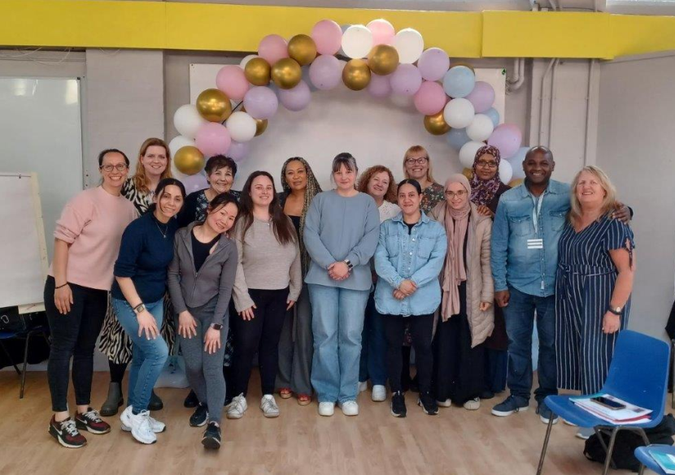
Volunteer Parent Group Leader Role

Why Become a Volunteer PGL (Parent Group Leader) with ZEST?
Empowering Parents, Empowering Communities (EPEC) is a successful, popular, unique parenting approach.
EPEC is for local parents, led by local parents.
EPEC has a well-tested and innovative combination of peer-led methods with professional parenting support and supervision:
Zest is looking for Parents city wide with energy and vision to work alongside our EPEC volunteer co-ordinator and Sheffield City Council Parenting Team.

Qualifications Needed:
No Formal qualifications are necessary, but we would expect volunteers to have personal parenting experience and be positive about supporting other parents and their communities in their parenting journey.
The programmes are aimed to help parents of children of a wide range of ages, from 0 to teenage years, including specialist approaches for autistic children and parenting together (extended and blended families).
Due to the nature of the role an enhanced DBS is required. 2 references will also be necessary to support your application.

Roles and Required Qualities:
EPEC groups are highly interactive, involving an engaging and creative blend of small and large discussion, demonstrations, information sharing and reflection. Real life examples, Parents practice and use new skills in everyday life to achieve specific goals.
We are looking for people who are:
- Parents/carers or people who have experience of parenting.
- Wanting to make a difference to families in your own community
- Good communicators, with a friendly and approachable manner.
- Able to listen/ share their own experiences, sensitively with others.
- Team players and able to build relationships with a wide range of people.
- Are compassionate, supportive and non-judgmental.
- Can give encouragement and motivation to families who need it the most.
- Are enthusiastic, committed, trustworthy and reliable.
- Are ready to learn new skills.

- Understand the importance of confidentiality.

Scan QR Code to watch video from EPEC PGL’s to find out more information about the EPEC Programmes.
This role is working with the Zest EPEC Team to:
- Plan and deliver parenting programmes in the community, with our support and guidance
- Connect with Local Parents, advertise groups in your local community to increase uptake.
- Build community capacity and resilience, helping families to connect and strengthen support networks.
- Building trusting relationships so that parents feel encouraged, optimistic and well informed about EPEC
- Help parents to develop individual plans and goals for themselves, their children and family (with their own parenting tool kit). Signposting them to further support where needed.

The Training will include:
- Initial EPEC Training consists of 60 hours in person training over 12 weeks (9.30am -2.00pm). Alongside this training some e-learning training modules will need to be completed, and a weekly reflective journal.
- Further Training opportunities will be available to enhance your professional development.

Support:
All Parent Group Leader volunteers receive free training and access to ongoing supervision and support from Lynn our EPEC Volunteer Co-Ordinator, Wendy our Volunteer Support Officer and Sheffield City Council Parenting Team as well as the National EPEC team.
You will Gain:
- Learn to lead practical, caring groups for local parents.
- Share tried and tested methods that give children the best start in life.
- Join a group of like-minded parents to make a difference to your local community.
- Opportunities to develop your skills and confidence, enhancing your personal development.
- Gain experience that will help you to fulfil your ambitions, including employment support.
- Opportunities to connect into Zest and a network of Early Years/ Parenting organisations.

Your Commitment:
- Full participation in the training programme, including completing weekly journals.
- Time to the project, delivering groups and attending planning/ supervision. (min of 3 hours weekly, term time.)
Benefits:
- Payment of travel expenses (on production of receipts) and child care expenses whilst training or delivering groups.
- Reduced rate gym and pool membership equivalent to staff discounted rate at ZEST Upperthorpe (after initial 6-week trial period and for the period you are volunteering).
- Continuing development sessions to exchange skills, reflect on practice, revisit and review course structures and organisation, and co-design new developments

For more information contact: Scan QR Code to Apply to become a PGL
Today!
Lynn Wragg

Mobile: 07792 191522 Email:lynn.wragg@zestcommunity.co.uk

Wendy Sweeney
Mobile: 07918 878975
Email: wendy.sweeney@zestcommunity.co.uk
Scan QR Code to Apply to become a PGL Today!



