

# Welcome to SEND at Stockbridge NI School

# SEND Policy & Information Report

|  |  |
| --- | --- |
| **Key People** | |
| **Mr Robert Barker** | **SEND Coordinator (SENDCO)**   * I lead and manage SEND in school.   **How to Contact me**   * [senco@stocksbridge-nur.sheffield.sch.uk](mailto:senco@stocksbridge-nur.sheffield.sch.uk) * 0114 288 3109 |
| **Mrs Jane Townsend** | **Headteacher**   * I lead and manage the whole school.   **How to Contact me**   * [headteacher@stocksbridge-nur.sheffield.sch.uk](mailto:headteacher@stocksbridge-nur.sheffield.sch.uk) * 0114 288 3109 |

**Welcome to Stocksbridge NI School**

**Pot House Lane, Stocksbridge, Sheffield. S36 1EJ**

Ages 3 –7

Our welcome booklet unites our **SEND Information Report** and **SEND policy**. This makes it easier for parents and staff to find SEND information more easily. Any questions or comments, please get in touch.

Our photos of children are chosen regardless of whether they have SEND or not.

This is inclusion.

|  |  |  |  |  |
| --- | --- | --- | --- | --- |
| Contents | | | | |
| 3 | What is SEND?  Our Ambitions |  | 12 | Our Team: Who’s Who |
| 4 | Types of SEND |  | 14 | Training for our Staff |
| 5 | Identification of SEND |  | 15 | Specialist Help |
| 6 | How we meet Children’s Needs |  | 16 | When Children Join or Leave |
| 7 | Assess, Plan, Do, Review |  | 17 | Our Buildings  Equipment for SEND Children |
| 8 | Targets |  | 18 | Your Questions Answered |
| 9 | The Role of Parents  Support for Parents |  | 20 | Complaints, Exclusions and Other policies |
| 11 | The Role of Children |  | 21 | SEND Laws  Monitoring this policy |

## The School on the Hillside

Stocksbridge NI is a school for 3 to 7 year olds in north west Sheffield. We have over 200 children in our 7 classes.



### What is SEND?

A child has SEND if they have a **learning difficulty** or **disability** that we need to make **special provision** for.

Some key terms explained:

* **Learning Difficulty:** when a child finds it harder to learn than most children do.
* **Disability (that we need to make special provision for):** something that hinders a child from using our school facilities.
* **Special provision:** is support that is extra or different to what is typically provided.

### What are our Values?

Every child with SEND can thrive. We do everything that we can to make sure that happens.

That means we:

* provide lessons that meet the needs of every child;
* make reasonable adjustments to lessons and our school environment;
* provide staff training to expand our SEND expertise.

### What are our ambitions for children who have SEND?

We are ambitious for all children with SEND. We want them to make excellent progress. This means they will know more, remember more and be able to do more, despite their SEND.

We want to give them the knowledge and skills they need for adult life. We think about both long term and short term.

In the long term, we want our children with SEND to:

* have excellent basic skills (especially in reading, writing and maths)
* have good friends and relationships
* live a healthy and independent life in the community
* be successful in work.

## What are the types of SEND?

**The four categories of SEND**

Schools follow the guidelines from the government’s SEND Code of Practice, where SEND is broken up into four categories:

### 1. Cognition and Learning (C&L), including:

* + Learning difficulties;
  + Dyslexia & dyscalculia;
  + Focus, attention or memory difficulties.

### 2. Communication and Interaction (C&I), including:

* + Autism / ASD;
  + Social communication difficulties (other than autism);
  + Speech & language difficulties (e.g. receptive or expressive language difficulties, selective mutism, tongue tie).

### 3. Social, Emotional Mental Health (SEMH), including

* + ADHD;
  + Anxiety;
  + Dysregulated behaviour.

### 4. Physical / Sensory needs, including:

* + Physical needs (e.g. cerebral palsy, dyspraxia);
  + Deafness or hearing difficulty;
  + Blind or visually impaired.

Some children have more than one type of SEND.

We welcome children with all of the above types of SEND who have applied for a place.

If a child has complex needs, we consider admissions on a case by case basis (through an Education Health and Care plan consultation). For more information on this, please contact the SENDCo.

**Identification of SEND**

5

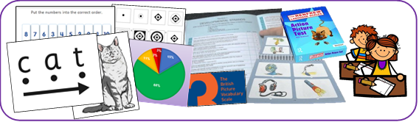

**How do we decide if a child has SEND?**

We will assess the child. This might be an assessment of reading, writing or maths. It could also be assessing a child’s social skills or behaviour.

Some parents give us extra information to help us make decisions. For example, this could be an eye clinic report about sight loss, or an autism diagnosis letter.

Sometimes our assessment might be quick. Sometimes SEND only becomes clear when we assess a child over a longer period.

When we assess, we always look out for:

* A child making less progress than their classmates;
* A child making less progress than they did before;
* A child not closing the gap between them and their peers (despite any extra help that we have given).

Sometimes, we ask outside experts to assess children and give us advice.

**Is it always SEND?**

Slow progress does not always mean a child has SEND. When we are assessing whether a child has SEND we also consider, for example:

* Attendance
* Issues in that child’s life (e.g. bereavement)
* Issues in school (e.g. friendships)

Often teachers address progress issues via adjustments to what is already on offer, without needing SEND provision.

A child does not have SEND just because English is not their first language (although they could have SEND as well).

Also, a child doesn’t have SEND just because they were born in summer term (and so have had less time in school than their September born classmates).

**How do we meet children’s needs?**

**Overview**

Children’s SEND are varied. Not all children need the same level of support. Where need is higher, we usually take more actions. Where need is lower, we might only need two or three adjustments.

We match the level of support to the child’s level of need. This matching is called our **graduated response**.

The levels of support are often called **waves**of support.

Schools have three waves of support:

* **Wave 1:** Support and opportunities that every child gets.
* **Wave 2:** Support and opportunities for children who need a little extra help.
* **Wave 3:** SEND support for children to meet their very individual needs.

Teachers and support staff all work at all levels of support.

|  |
| --- |
| **Wave 1**  This is quality teaching lead by the class teacher. It includes: |
| * Teachers who are ambitious for all their children. * Well planned lessons that are differentiated (i.e. adjusted) to engage all children. * Resources that help all children succeed (e.g. writing frames, number lines). * Opportunities for children to practice and use their learning in different situations. * Teachers assessing children to help them know when to move on and what to teach next. * Behaviour and reward systems that motivate children. |

|  |
| --- |
| **Wave 2**  This is for children who need extra support to catch up with their peers. It is often small group work, either in the classroom or elsewhere in school. For example: |
| * Booster classes for English or maths. * Extra teaching assistant support in lessons. * Extra phonics sessions in a small group. * Social skills groups. * Emotional regulation support. |

|  |
| --- |
| **Wave 3**  This means personalised SEND interventions. For example: |
| * Phonics support. * Work to help fine motor skills (e.g. fine motor, hand strength exercises). * 1:1 speech therapy work. * Social Stories. * An individual positive behaviour programme. * Physiotherapy work. * Tweaks to the child’s environment (e.g. a visual timetable, a calming area). * Person-centred plans (e.g. Learner Profile, SEN Support Plan, Extended Support Plans) |

The SENDCo keeps a grid of our Wave 2 and Wave 3 SEND programmes. We call this our *Provision Map.*

### Assess, Plan, Do, Review

All our SEND support fits into a four-part cycle called *Assess, Plan, Do, Review.*

Assess: We decide what the child’s needs are.

Plan: We set targets. We decide how we support the child to meet these targets.

Do: Everyone follows the plans we’ve agreed.

Review: We look at how well the plans worked. We agree what to do next.

Each cycle takes one school term and there are three cycles per year.

Sometimes this timescale is shorter (e.g. we are working on an important safety target or because the child is very young and is changing quickly).

**Targets**



**SMART Targets**

We set targets for children with SEND so that staff, parents and children know what we are all working towards. These targets are part of a child’s SEND Support Plan or My Plan.

We often call these **SMART** targets. SMART targets are:

* **S**pecific: We say exactly what the next small step will be for the child.
* **M**easurable: We say how we will know if the child is meeting the target.
* **A**chievable: We will be ambitious for the child, but it still needs to be achievable.
* **R**elevant: We link it to the child’s difficulties or what they need to achieve next.
* **T**ime bound: Targets are normally set to for one term (10-14 weeks).

**How are Targets Specific?**

Specific targets say what the child **will be able to do**. We avoid words that are vague. Instead, we use action words to write targets (e.g. read, write, take turns).

|  |  |  |
| --- | --- | --- |
| **Vague Words**  (We avoid these) | **Specific Action Words**  (We use these) | **Examples** |
| Improve | Add | Jo will add numbers up to 6 using apparatus (e.g. cubes). |
| Continue | Read | Jo will read all Phase 4 tricky words. |
| Develop | Say | Jo will say sentences that include where or when something happened (e.g. “In the water, the shark hunted her lunch”; “The woodcutter ate his lunch when the sun was high”). |
| Behave | Use | Jo will use calming strategies (e.g. blutack, weighted dog, time out) when he is anxious in class. |

**The Role of Parents**

**Teamwork with Parents and Families**

(For ease of reading, the word “parents” is used to mean anyone who has parental responsibility, including carers).

Parents are a vital to the success of children with SEND:

* Their knowledge helps us to get a complete view of a child's SEND.
* They tell us what strategies work well at home (often good ideas from home can help the child in school).
* Parents attend termly SEND Reviews so we can review their child’s progress as a team.
* Parents use ideas from school to help the child at home.
* Parents share useful information with us to help us meet the child’s SEND (e.g. clinic reports).

When we think a child might have SEND, we discuss this with parents. This is so that we can:

* Find out more about the parent’s views;
* Chat about what the next steps might be (this might include setting targets);
* Agree some long term goals (we might refer to these goals as outcomes).

Excellent teamwork between us and parents is very important to us.

**Co-Production**

The word *co-production* means parents being a key part of planning SEND support and what’s provided for SEND.

Co-production is really important to us. Parents help by coming to SEND reviews and giving their input or by keeping us up to date on their child’s life.

Just as importantly, parents help us to improve our SEND support through our yearly parent survey, giving views on our latest SEND documents (parents helped us to produce this document) and giving ideas for our next parent workshops.

## Support for Parents

### SENDIAS

SENDIAS is a service that provides **independent advice and support** for parents.

The service is free.

They offer a range of help:

* Info on local groups and services
* Info on SEND laws
* Help to prepare for meetings
* Help to solve disagreements

### How can parents access SENDIAS?

Parents don’t need anyone to refer them to SENDIAS. They can just get in touch:

* Tel: 0114 273 6009
* Email: ssendias@sheffield.gov.uk
* Web: [sheffieldsendias.org.uk/](https://sheffieldsendias.org.uk/)
* Facebook: [facebook.com/SheffieldSENDIAS/](http://www.facebook.com/SheffieldSENDIAS/)
* Instagram: [instagram.com/sheffield_ias/](http://www.instagram.com/sheffield_ias/)

### The Local Offer

The Local Offer is a website that is written for parents and families. It is a guide to all schools and services in our area. It is not possible to outline all the information here, but it does include:

* Schools
* Leisure activities
* Holiday activities
* Support services
* Health services (e.g. contact details for the speech and language therapy team)

Our staff, SENDIASS and the Local Offer can all help parents through the SEND maze.

## The Role of Children



The role of children is to **do their very best** so that they **learn more, remember more** and **can do more** for the rest of their lives!

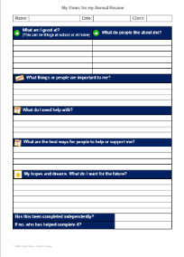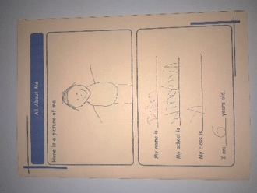It is also important that adults listen to the views of children with SEND. The child’s input can help us unlock extra progress. Collecting child views may include:

* Asking or observing the child.
* The child completing a survey.
* The child self-assessing their behaviour targets.
* The child coming to their SEND review meeting.
* An annual survey of SEND children.

How we collect child views depends on the child’s age and development.

### C**an a child with SEND join in day trips, residential trips, breakfast, after school and holiday clubs?**

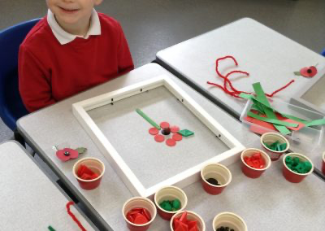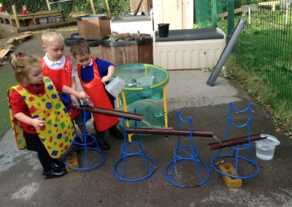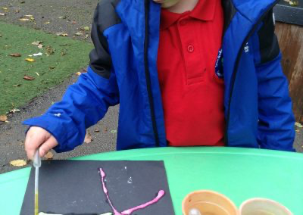

Yes – we make adjustments so that children who have SEND can join in all of school life.

Staff may need to talk to parents to plan adjustments. Or, a parent can talk to their class teacher or the SENDCo about if they are worried that their child might need adjustments to be successful.

It is very rare that we have to make the hard decision for a child to not attend – in the very small number of occasions this is due to safety, wellbeing or both.

## Our Team: Who’s Who?



Check out <https://www.stocksbridgenurseryinfants.co.uk/staff/> to see all our team**.**

**Our SENDCo, Mr Robert Barker, leads and manage SEND at Stocksbridge.**

* He oversees and co-ordinates SEND provision for children with SEND.



* He supports and guides staff and parents so that children with SEND have both high-quality teaching and ambitious support.
* He advises on the use of school’s SEND budget and resources to meet children’s SEND.
* He works with the head teacher to plan how we will enhance our SEND work.
* He identifies training needs and make sure that SEND INSET enhances staff skills.
* He liaises with Early Years settings and other schools to help a smooth transition both in and out of our school.
* He acts as the key contact for external SEND support services.

**Our Headteacher is Mrs Jane Townsend:**

* She leads our school.



* She leads and manages the staff team, including the SENDCo.
* She checks on the quality of our work. This includes SEND provision.

## More about our Team

**“Every teacher is a teacher of SEND”**

**“Every teacher is a teacher of SEND”**

**What do our teachers do for SEND?**

* Teachers are responsible for the development of *every* child they teach.
* Teachers work closely with support staff to plan and review support.
* Teachers adjust lessons to make them accessible for every child.
* Teachers use assessments to plan inclusive lessons.
* Teachers follow advice from any support services.
* Teachers review each child’s progress and plan the next steps.

**What do support staff, including teaching assistants, do?**

Support staff are a key part of our team.

* They help children reach for the stars.
* This includes supporting children during lessons and also leading both SEND groups and 1:1 work inside and outside of the classroom.

**Our SEND Governor is Sarah Briggs:**

* She overviews long term plans for improving SEND in school.
* She monitors SEND in our school. This includes our legal duties.
* She meets with the SENDCO through the school year.



**How do our team develop their SEND Expertise?**

Our team have lots of SEND expertise. However, it is important we refresh and develop our learning and further develop our skills.

To train and develop our team, we use:



* Staff meeting and INSET day training
* Staff supporting each other
* Online courses and webinars
  + e.g. AET <https://www.autismeducationtrust.org.uk/>
* Online information
  + e.g. NASEN’s *What Works:* [www.sendgateway.org.uk/page/what-works](http://www.sendgateway.org.uk/page/what-works)

**What training have we had?**

In the last three years, members of our staff team have had training on:

**Learning**

* Monster Phonics
* Birmingham Toolkit
* Word Aware
* Precision Teaching
* ReflectEd

**Social Skills and Language**

* Making Sense of Autism
* Attention Autism
* SCERTS training
* Makaton
* Lego therapy
* LEAP and VIP
* Cued articulation
* Developmental Language Delay

**Wellbeing and Behaviour**

* Adverse Childhood Experiences
* Anxiety
* Attachment
* Emotionally Base School Avoidance
* Healthy Minds
* Positive Regard
* Mental Health
* Trauma Informed Schools
* Theraplay
* Zones of Regulation

**Other**

* The Sheffield Support Grid
* Primitive Reflexes/Born to Move

## Can school access specialist help?

Some children have very specific or complex needs.

We work with support services to meet their needs so that we can get advice from high-level experts.

We sometimes call these support services “external agencies.”

|  |  |
| --- | --- |
| **Support Services** | |
| Learning Support Teachers  * Contact details via SENDCo | Speech and Language Therapy  * 0114 226 2333 |
| Educational Psychology (EPS)  * 0114 250 6800 * Moorfoot Building, Sheffield, S1 4PL | Mainstream Schools Therapy Service  * Physio and OT * 0114 271 7610 |
| Autism Team  * 0114 250 6800 * autism.educationteam@sheffield.gov.uk * Floor 4 North Wing, Moorfoot Building, Sheffield. S1 4PL | Child Mental Health Support (CAMHS)  * 0114 271 6540 * CAMHS SPA, Centenary House, Heritage Park, Albert Terrace Road. S6 3BR |
| 0 – 5 SEND team  * 01142 736411 * [elizabeth.hodkin@sheffield.gov.uk](mailto:elizabeth.hodkin@sheffield.gov.uk) | DCD Team (Jenny Featherstone)  * 0114 271 7610 |
| Deaf & Hearing Impaired Team  * 0114 273 6410 * Caroline.chettleburgh@sheffield.gov.uk * Floor 4, North Wing, Moorfoot, Sheffield. S1 4PL | Community Continence Service  * 0114 305 3240 * Children’s Community Continence Clinic, Centenary House, 55 Albert Terrace Road. S6 3BR |
| Visual Impairment Team  * 0114 2941201 * 0114 2941171 * Jhogg@taptonschool.co.uk | Community Paediatrics  * 0114 305 3378 * Centenary House, Heritage Park, Albert Terrace Road. Sheffield. S6 3BR |
| Sheffield Teaching Team  * Support for children in hospital for more than 3 days. * 0114 271 7146 * scn-tr.auditbhot@nhs.net | Epilepsy Nurses  * 0114 271 7620 * 0114 271 7621 |
| School Nursing Team  * 0114 305 3224 * Centenary House, 55 Albert Terrace Road. S6 3BR | Ryegate Children’s Centre  * Autism Assessment Clinic * 2717656 * Tapton Crescent Road, Crosspool. S10 5DD |
| Audiology  * 0114 271 7450 * Based at Sheffield Children’s Hospital | FIS (Family Intervention Service)  * 0114 203 7485 * childrenandfamiliesmast@sheffield.gov.uk |

For many children with SEND, we can meet their needs without needing support services. This is because our staff have knowledge and skills to adapt learning to meet the needs of most SEND.

If we think extra advice from an support service is needed for a child, then we discuss this with the parent first. Parents normally understand the many benefits for their child, but if they have questions they are welcome to chat to the class teacher or a SENDCo. The parent makes the final decision.

Support services advise teachers and/or the SENDCo. Teachers make sure advice is followed and the SENDCo monitors this.

## When Children Join or Leave Us

(This is called transition)

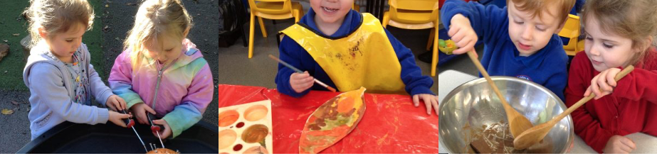

**How do we help children joining our school?**

* We meet parents and any nursery, childminder or current school to find out about the child’s needs.
* We provide a Welcome to School booklet.
* The child visits school and gets to meet the adults in their new class.
* The child can have extra visits if needed.

**How do we help children leaving our school?**

* We link with the next school to share SEND information. This is often Stocksbridge Junior School, but can be others.
* We often support children having extra visits or talk to children about any worries about their new school.
* Transfer into junior school is normally led by the junior school. You can find more about how they manage this in their SEND Information Report.
* We invite the SENDCo of child’s junior school to the Y2 summer SEND review.

We take the same approach if a child with SEND leaves our school before the end of Y2 (e.g. because of a house move). If a child moves school quickly or further afield, we may tweak our support (for example, there is not a SEND Review before they move.

**Transition between Year Groups**

* Before the end of the summer term, teachers pass on SEND information to the new teacher and the child gets to visit their new class.
* If needed, extra visits to the new class or transition booklets are provided to help children with SEND have a smooth transition to their brand new class.

## Our Buildings: Indoor and Outdoor

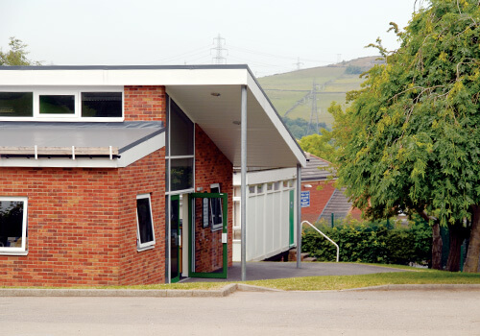

Our school is made up of one building built on the hillside. We have added extra classrooms as our school has grown.

Our building has:

* Step free access
* An accessible toilet
* Handrails

Foundation Stage has classrooms with access to outdoor space. It has:

* Mostly step free access with additional handrails where appropriate.
* Accessible toilets

The playgrounds have fences with electronic gates. We have playgrounds and are lucky enough to have lots of outdoor space, including a forest school.

## Extra Equipment for SEND

Some children need extra items to help them be successful at school. Most of these are not expensive and we buy these from our budget.

From time to time, equipment costs much more than this (e.g. hoists, hearing aid loops). If so, we might ask for extra funding from Sheffield Council’s SEND funds. We do not ask parents to pay for SEN provision from their own money.

**Your Questions Answered**

**1. Does a child need a diagnosis in order to have SEND?**

No. Some children do have a diagnosis (e.g. autism, ADHD), but we can address a child’s SEND even if they don’t have a diagnosis.

We know that families often want diagnosis so that they can be sure what is going on for their child. But, it’s also important that we help the child as soon as we can – so we don’t need to wait for a diagnosis to make adjustments for a child.

**2. What is an EHCP?**

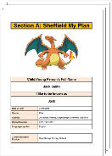EHCP is short for *Education, Health and Care Plan.* Thisis like a contract between a local council, school and parents.

Most children’s SEND can be met without an EHCP - we use our SEND funding to do this. Some of these children will have My Plans (a plan that sets out their needs and how we’ll meet them).

A small number of children with more complex SEND have an EHCP (about 2% of all children). Some of these children are in special schools and some are in mainstream schools.

More information on EHCPs can be found on the Local Offer website or you ask either of our friendly SENDCos about EHCPs.

**3. Are emotional difficulties always SEND?**

No. Some children have time when they are withdrawn or sad (e.g. because of a death of a family member or loved pet).

If a child is distressed this is often short term. We have a range of emotional support we can offer, depending on a child’s difficulties.

Some adverse experiences lead to longer term or more severe emotional issues. If so, the child’s difficulties might be assessed a SEND.

**More Questions Answered**

**4. What support is available for social and emotional needs?**

We are proud to be a caring, nurturing and supportive school. We believe that children need to feel happy, secure and safe in order to meet their potential. Every child is treated as an individual.

If a child is exhibiting challenging behaviour we try to find the causes and then adapt so we can alleviate the behaviour.

Some of our support is available to all children:

* Class circle time
* School assemblies about emotions and feelings
* Posters tell children who they can talk to if worried (our safeguarding team)
* Clear systems for managing behaviour
* Play equipment for children to enjoy at playtime and lunch time
* Staff who offer pastoral support

Some children also have extra support, including:

* Zones of Regulation lessons to learn thinking skills.
* Small groups to support social skills, these are called:
* Imagination Gaming
* Nurture
* Behaviour Support Plans help some children regulate their emotions.

**5. Why don’t school include a child with autism or ADHD as having a sensory need on the paperwork or the school SEND register?**

Every school has to follow the government’s SEND handbook. This is called the SEND Code of Practice. It tells us what categories of SEND we are allowed to use and what each category means.

The government’s category “Physical / Sensory Needs” includes three specific sensory needs:

* Visual impairment: Loss of some or all of their sight;



* Hearing impairment: Loss of some or all of their hearing;
* Multisensory impairment: Loss of some or all of both their hearing & sight.

Each of these sensory needs refers to the loss of sight and/or hearing.

Children with ASD or ADHD can also have sensory needs but they have not lost the use of their senses. It’s more that they might be over or under-sensitive to sights, smells or sounds etc. Their needs are usually about processing of sensory information rather than loss of vision or hearing.

Although we can’t put these needs into the government’s sensory needs category, it doesn’t make a difference to the support that the child receives.

## Other Information

### Exclusions

We reduce the risk of exclusions by making adjustments to help everyone fully access life in school.

However, you can find out more about exclusions in our **Behaviour Policy** [here](https://www.stocksbridgenurseryinfants.co.uk/policies/).

### Evaluating our SEND Policy

We have five key ways to check how well our SEND policy is working:

1. Monitoring the progress children have made.



1. Monitoring how well children with SEND meet their SMART targets.
2. Regular reviews of interventions with teachers and support staff.
3. Our leadership team visit classrooms to observe and look through children’s books.
4. Listening to the views of parents, families and children.

Our SENDCo and leadership team are in charge of evaluating our SEND policy.

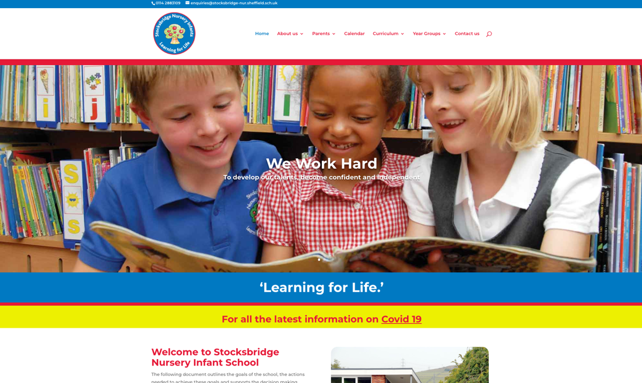

### Where to find more SEND Information?

Visit our website, <https://www.stocksbridgenurseryinfants.co.uk/>, to read other policies that link to SEND:

* **Accessibility plan**

A three year plan to be a more inclusive school.

* **Behaviour Policy**

Rewards, rules, sanctions and much more.

* **Equality information and objectives**

How we tackle discrimination, make school life equal and promote good relations between everyone.

* **Medical Policy**

Support for children with medical conditions and what we do about medicines.

### Want to read more?

If you want to read more, these are the key SEND rules and laws:

**SEND Code of Practice**

* 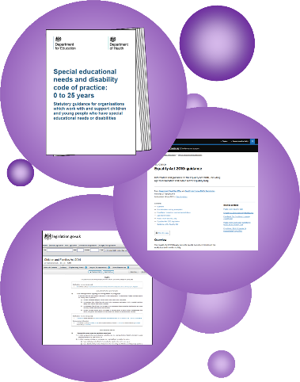This is the Government’s SEND rulebook.
* Find out more [here](https://www.gov.uk/government/publications/send-code-of-practice-0-to-25).

**Equality Act**

* This 2010 law outlines our duties to make reasonable adjustments and not discriminate.
* Find out more [here](https://www.gov.uk/guidance/equality-act-2010-guidance).

**The Children & Families Act**

* This 2014 law outlines our duties for children with SEND.
* Find it [here](https://www.legislation.gov.uk/ukpga/2014/6/part/3).

### Status of our SEND Policy

This policy is statutory. That means that the law says schools must have a SEND policy and a SEND information report. **The DfE say that these can be a single document.**

We use a single document so that it is easier to find out about our SEND work. This booklet has all the essential parts of both the SEND Information Report and SEND Policy.

### Evaluating our SEND Policy

The SENDCo and other school leaders have five key ways to check how well our SEND policy is working:

1. Monitoring how much progress children have made.
2. Monitoring how well children with SEND are meeting their SMART targets.
3. Regular reviews of interventions with teachers and support staff.
4. School leaders visit classrooms to observe, or looking through workbooks.
5. Asking parents and children about SEND in our school.

### Reviewing this policy

We review this policy every 12 months. Our SENDCo is in charge of the policy review. Then, our governors discuss and approve it.

This policy was approved by governors on 7th March 2024.

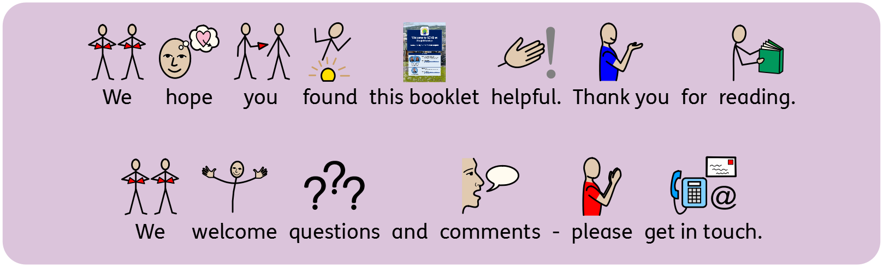

‘‘

An inclusive school is a great benefit to everybody – not just children with SEND, but it’s a great benefit to all of us, to share in our humanity…

It just makes us into better people, doesn’t it?

If we want to make society a more inclusive place, why would we leave our schools until last?

”

Sarah, a parent, gives her views in a 2019 report about access and inclusion *“Effective Tools for Inclusion in Schools?”*

