**Stocksbridge Nursery Infant**

**School**

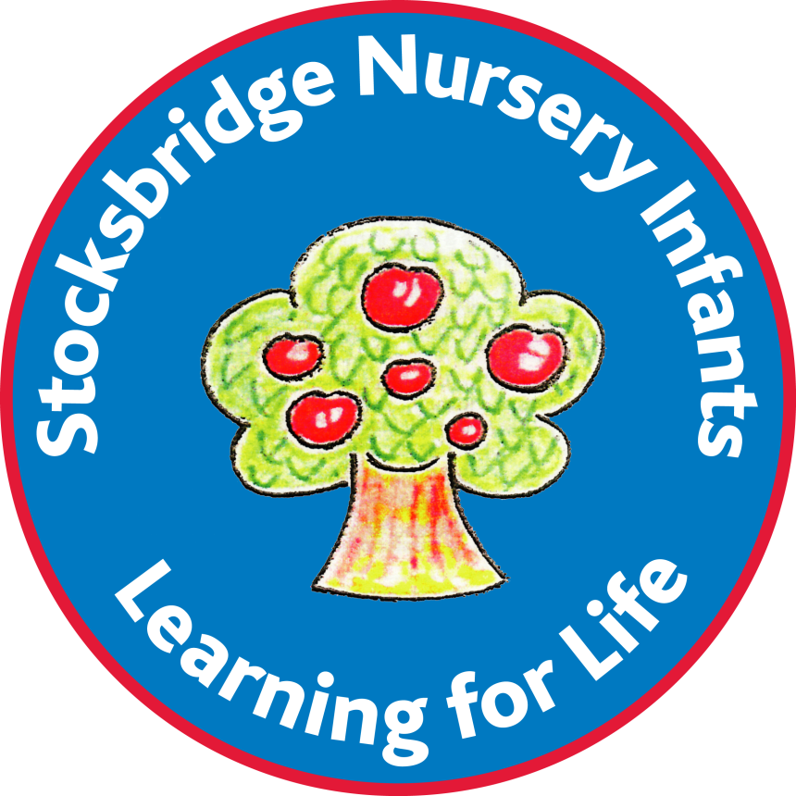

**Admission Policy**

Policy adopted: December 2021

Policy review date: June 2025

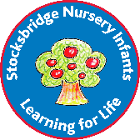**Stocksbridge Nursery Infant**

**Admission Policy**

**Admission into Reception at Stocksbridge Nursery Infant School from September 2015 and Subsequent Years**

All 4 year old children can start Stocksbridge Nursery Infant School, full or part-time, in the September following their 4th birthday. Parents may defer entry to school until compulsory school age if they wish, i.e. the term after the child’s 5th birthday, within the same academic year.

**Each parent carer will need to consider their child’s ‘readiness for school’ before deciding when to start. This will depend upon both the age and stage of development of individual children. Each child’s independence is an important consideration; for example can your child dress and undress themselves, go to the toilet independently etc.**

Parents are able to choose from the following options depending on when their child reaches compulsory school age i.e. the term after their 5th birthday:

**Children who have their 5th birthday between 1st September and 31st December:**

:

* A full-time school place in the Reception class from September

**OR**

* A part-time school place in the Reception class from September

**OR**

* A part-time place in an early years setting (15 hours)

**These children must start school in January full-time as they have reached statutory school age**

**Children who have their 5th birthday between 1st January and 31st March:**

* A full or part-time school place in the Reception class from September

**AND/OR**

* A full or part-time school place in the Reception class from January

**OR**

* A part-time place in an early years setting (15 hours)

**These children must start school in April full-time as they have reached statutory school age**

**Children who have their 5th birthday between 1st April and 31st August:**

* A full or part-time school place in the Reception class from September

**AND/OR**

* A full or part-time school place in the Reception class from January

**OR**

* A part-time place in an early years setting (15 hours)

**Wait until compulsory school age – the following September of the next academic year. This will be a direct entry into Year 1 and parents will have to re-apply for a school place. A school place cannot be guaranteed.**

**Parents must note**:

* Attendance at the school’s nursery does not guarantee admission to the school and a school place in Reception must be applied for – please see the ‘Guide for Parents’ page 31 available from Pupil Admissions or view guidance on-line at: <https://www.sheffield.gov.uk/home/schools-childcare/apply-school-place>
* Parents can request that the date their child is admitted to school is deferred until later in the school year or when the child reaches compulsory school age in that school year.
* When your child has been allocated a place at Stocksbridge Nursery Infant School, transferring from an early years setting or home into Stocksbridge Nursery Infant School is guaranteed as the school place remains available throughout the whole academic year.
* A part-time place is a morning session of up to a maximum of 15 hours per week. Part time school should be discussed with school and is dependent on a child’s date of birth. However we will listen to any exceptional circumstances that require greater flexibility. Please contact the school directly if you would like more information.
* A full-time school place cannot be split between a school and an early years provider.
* A part-time school place cannot be split between two or more schools.
* Where a parent wishes to transfer from an early years place to a school it will normally take effect from the beginning of the term.
* Parents who do not wish to accept the offer of a full or part-time place until compulsory school age at Stocksbridge Nursery Infant School may still access the 15 hours part-time free early learning place at an early years setting of their choice e.g.
  + In a nursery class at a primary school
  + In a nursery school.
  + In an eligible early years setting in the private, voluntary and community sector.

Stocksbridge Nursery Infant School will endeavour to learn and understand the needs of each child through transition meetings prior to the child starting school. Parents are welcome to make an appointment with the Headteacher to discuss their child’s needs and seek advice about the option most suitable for their child.