Stocksbridge Nursery Infant School

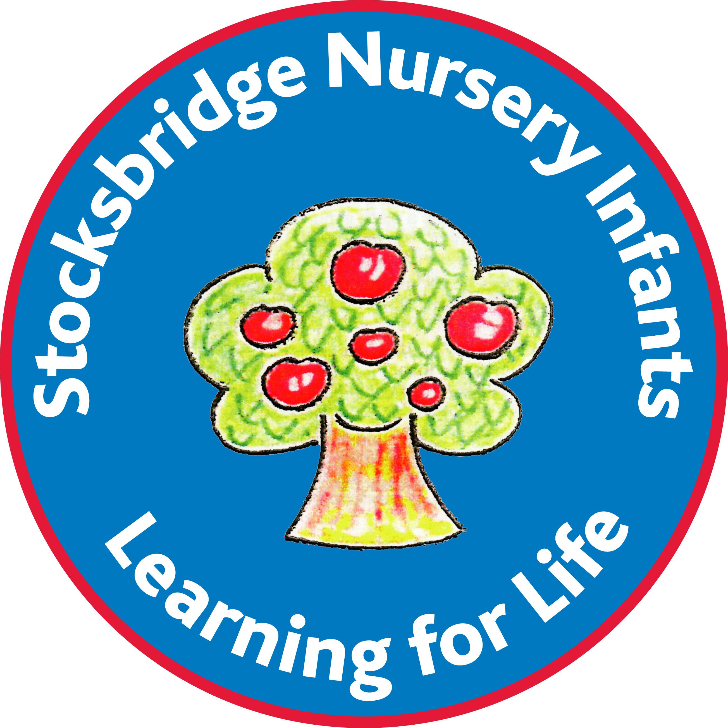

Strategic Plan

Realising the potential of our community – staff, parents and pupils

Foreword

We are pleased to present our long-term strategic plan for Stocksbridge Nursery Infant School.
Our intention in developing the plan is to set out and communicate our vision, ethos and long-term direction for the school, so that we are all clear on where we are going and what we are trying to achieve.

We are all very proud of our school’s achievements and the ethos and culture in which these are achieved. The school has many strengths and these have been ratified by the last 3 good Ofsted inspections. We have made excellent progress in many areas of school life and we plan to move the school forward to achieve excellence and an outstanding judgement within 3 years.

We would welcome any comments or suggestions.

Strategic Governor Committee:
Sarah Briggs, Jane Townsend, Jo Wilkinson, Eric Wright.

Contact details: Headteacher@stocksbridge-nur.sheffield.sch.uk

Contents

- Plan development and review
- School context, history and development
- Vision, motto and values
- Strategic Priorities
- Implementation, monitoring and evaluation
- Organisational structure

- Plan Development and Review

  - What and who?

The strategic plan is a high level, long term plan extending over a period of 3 years from 2024-2027. It sets out the school’s vison, values and long-term strategic priorities. It is aimed at the key stakeholders in the school, children and their parents, staff, governors and other stakeholders.

The strategic plan is complemented by the School Improvement Plan (SIP), a shorter-term operational plan extending over a period of 1-2 years. The SIP is developed by the staff and sets out in operational terms how the long-term strategy of the school is to be achieved.

  - How we developed the plan

The plan was developed by the governing Board working with staff and parents as follows.
- A meeting was held in September 2024 attended by a core group of governors and the Headteacher. The focus of this meeting was to bring initial thoughts re how to develop the plan for the school.

The development of the plan involved input from:
- Governors
- Staff
- Parent views – from the annual questionnaire responses.
- Feedback from Ofsted December 10th & 11th 2019.
- Children

  - Review and revision of plan

The plan will be reviewed annually at the first Governing Board meeting of the school term. It will be revised every three years.

- School context, history and development

2.1 Brief description

Stocksbridge Nursery Infant School is a maintained community school. The age range is from 3 to 7 years (Nursery to Year Two) with three-form entry with a school role of 209 (Sept 2024). It is an average sized school. The school has had falling numbers in recent years due to a low birth rate.

2.2 History

Stocksbridge Nursery Infants in the north west of Sheffield, which lies approximately 10 miles from the city centre. The school was built in 1955 to serve the town of Stocksbridge and the surrounding rural area. The school site and premises are secured by fencing. The school has sought to modernize the building gradually over the last 10 years with the addition of a new office block, new doors and windows, heating, alarms, redecoration, carpeting and sink refurbishments.

2.3 Community

The local community is mainly white British although the school is seeing an increase in pupils with English as an additional language. Most of our children (around 90%) are from within catchment. A growing number of children enter Reception directly from other providers. This year 40% of them attended provision other than our Nursery.
This year the school has a 78 place Nursery. In the two years previous to this plan the school was affected by a fall in the birthrate in Stocksbridge & Deepcar and Nursery was reduced to 52 places during the autumn term to reflect this. The proportion of pupils eligible for a free school meal is lower than average but rising (27.2% school / 17.3% Nationally in 2024).

2.4 Performance History, Ofsted Rating

A brief summary of how Ofsted has rated the school performance is given in the table below.

In the inspection in December 2019, Ofsted reported that we continued to be a good school.

The following were identified as areas we could improve.

- Leaders are now at a point to incorporate teachers’ ideas into planning and resourcing lessons. Teachers should support leaders to evaluate each unit of work and adjust them to make them even more effective in order to help pupils remember their learning.
- Pupils do not yet know enough about cultures and religions different to their own. Leaders have put plans into place to address this, but they must continue to develop this work to ensure that pupils have opportunities to develop the knowledge they need to prepare them for life in modern Britain.

Date | Ofsted Rating
February 2008 | Good
March 2011 | Grade 2: Good
May 2016 | Grade 2: Good
December 2019 | Grade 2: Good

- Vision, motto and values.

  - Vision

Our vision is one of confident and responsible pupils, who are independent, happy and motivated to enjoy learning.
They will have high expectations for themselves and have access to a stimulating, broad and balanced curriculum which enables them to meet their maximum potential.
Our children will act as caring, tolerant young citizens who are respectful of themselves and others.
They will have a wide range of skills to enable them to be good communicators in a variety of ways.

  - Motto

Learning for life

  - Values

Our values align closely with those of Peak Edge Trust.

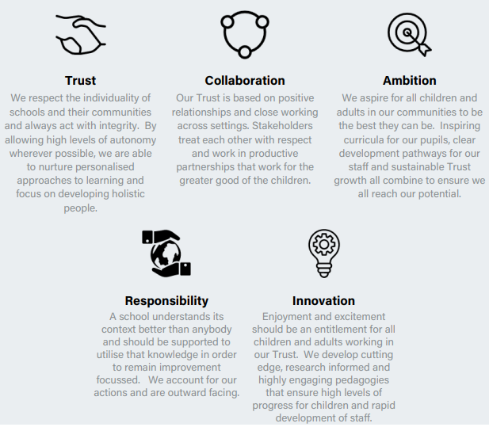

We care.
We all feel safe.
We are a happy school.
We show respect.
We are friendly.
We enjoy learning.

- Strategic Priorities

- Teaching is always good or outstanding.

We support the development of robust appraisal and effective strategies for improving teaching based on the individual needs of staff to meet the needs of all pupils particularly those eligible for FSM, those with SEND and those who are disadvantaged.

- To build a culture of success and achievement

Supported by educators who feel that all children can achieve and be successful

To develop children who are aspirational, who want to continually develop and extend their learning as well as being confident, independent and resilient.

We monitor and evaluate pupil progress to track pupils’ progress and challenge underachievement.

To monitor, evaluate and plan provision to ensure a child’s wider needs are met – personal, social, emotional and health.

- To develop an aspirational and inspirational curriculum.

We plan a curriculum that is based around core concepts, offers breadth and is both creative and challenging. It focuses on the development of key skills. The curriculum is enriched by visits, visitors and experiences.

We create learning bringing together areas of the curriculum, developed as themes which are designed to follow children’s interests and which are fun, exciting, relevant and engaging.

We deliver a curriculum that is well sequenced with opportunities for children to recap learning.

We deliver a curriculum that provides positive, memorable experiences and rich opportunities for high quality learning; has a very positive impact on pupil’s behaviour and safety; where personal, social, moral and emotional education is at the core.

We develop children’s confidence through a curriculum focused on active, hands on learning; where play is highly valued, supported and extended through skilled interactions.

We work hard as a community, celebrating the achievements of all.
We recognize parents as the first educators, fostering positive, respectful relationships between school, parents and those responsible for their welfare and education.

Teach the children to value and celebrate diversity within school and beyond.

Help the children to be respectful for themselves, others and the world in which they live.

- Strengthen collaboration with local schools working to benefit children and families.

We evaluate the work of the school within the Trust, the Locality and city wide with regards to the impact this is having on our children and families.

- Prioritise excellence in inclusive practice

We evaluate SEND practice within school and support the school’s drive to lead t and Locality in improving inclusive practice across the city. We continually review our practice to meet the growing, changing and diverse needs of our pupils. We strive to uphold the principle of Peak Edge Trust.
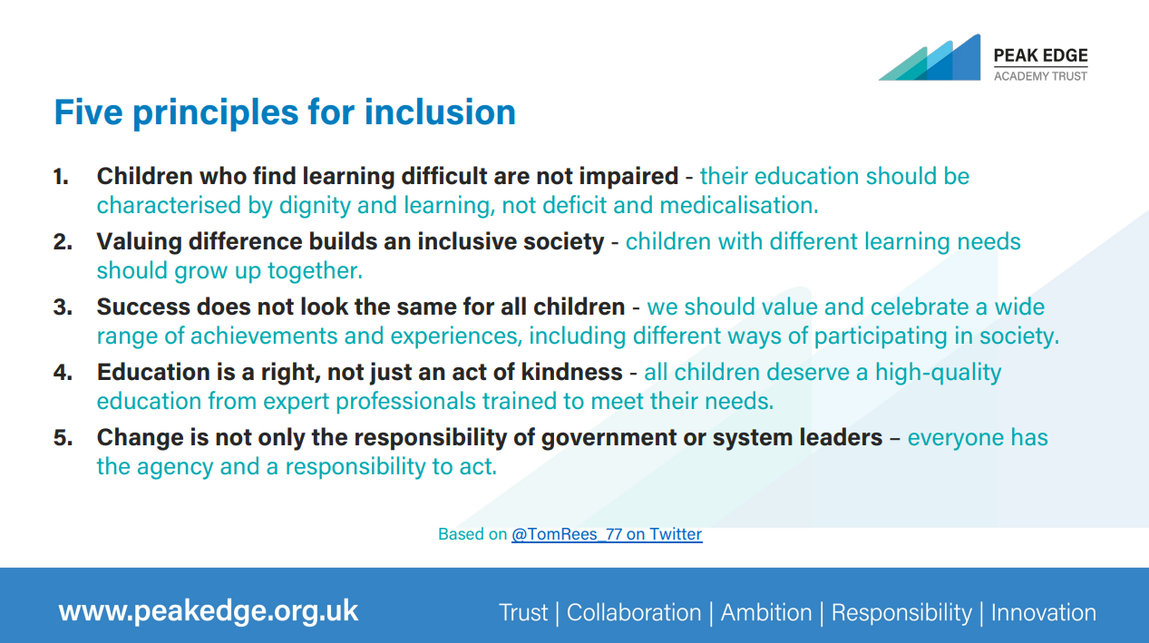

- Grow leadership capacity throughout school

Governors contribute to the strategic direction of the school ensuring clarity of vision and ethos.

We develop efficient processes that support and monitor the leadership team of the school.

We seek out excellent practice, develop collaboration to share best practice and have a focused coordinated approach to professional development; we seek to grow our own workforce, to spot potential, encourage it and support CPD to allow colleagues to achieve their ambitions in education.

- Prioritise excellence in staffing.

We monitor the recruitment, management and retention of staff.
We believe in growing capacity from within implementing school wide approaches that support engaging and challenging learning environments.

- Continued strong financial management.

We oversee, monitor and implement strong financial control.

- Improve the school environment

We value how the school looks and feels.
We support the school to continually develop its branding.
We continue to enhance the physical learning environment both indoors and outdoors.

- Implementation, Monitoring and Evaluation

  - Implementation of the plan.

The strategic plan sets out nine priorities and gives long term direction for implementation. The SIP describes how this strategy is to be implemented in the short term.

  - Monitoring

Each committee on the governing Board monitors the development and implementation of the SIP. The committees report on this to the full governing Board.

  - Evaluation

The governing Board will use the Trust, independent consultancy reports and Ofsted as a key evaluation tool.

- Organisational Structure

  - Governance Structure

The diagram below illustrates the governance structure of Peak Edge Trust.
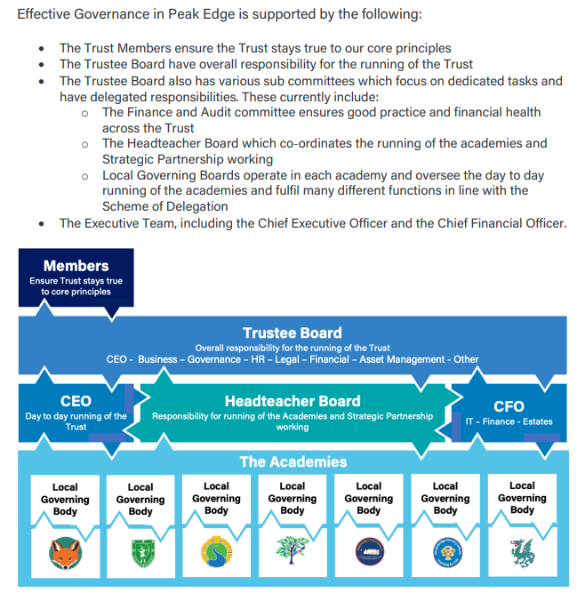

The following diagram illustrates the governance structure of the school.
The school’s pupils are served by the staff, led by the Headteacher to whom staff are accountable. The Headteacher is accountable to the Peak Edge Trust and the Governing Board (GB), each of which provides support and guidance.

The Governing Board is appointed from parents and the community including the Local Authority. A key relationship if that between the chair of the GB and the Headteacher. The GB has 4 committees:

Strategic
Standards and Curriculum
Resources including finance, premises and personnel.
Appraisal and Pay matters.

Parents provide direct support to staff and the school through Friends of Stocksbridge Nursery Infant School (FOSNI)

 | School pupils
Parents |  |  | Staff
 | FOSNI |  | Head and LT
 |  |  |  |  |  |  |  | Peak Edge Trust
Community |  |  |  |  | Chair
 |  | Governing Board
 |  | Strategic |  | Standards & Curriculum |  | Resources |  |  | Appraisal & Pay Matters

