 |  | Autumn 1 | Autumn 2 | Spring 1 | Spring 2 | Summer 1 | Summer 2
Theme title |  | Me and My City | Megastructures | Around the World in 80 days and beyond | What’s it like in Africa? | Panic on Pudding Lane | Living things and their habitats
Theme led by…. |  | Geog, history, DT | DT  Science | Geog, history, DT | Geog, science, DT (food) | Geog, history, Science | Science  DT
Substantive Concepts (knowledge)  Disciplinary concepts (skills) |  | Community  Leaders |  | Leaders | Community | Community  Leaders
SPARLING STARTER…  Fabulous finish |  | City tour  Walks around Stocksbridge | Hepp DT company  YSP | Amy Johnson actress (first lady to fly around the world)  Exhibition of learning | African drumming/dancer | Visit to Eyam  Great Fire of London- burning models | Wetlands centre  Hepp DT
English including book focus |  | Year 1  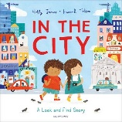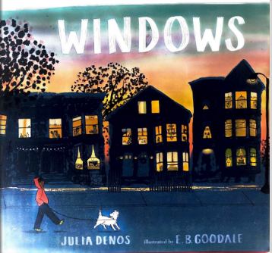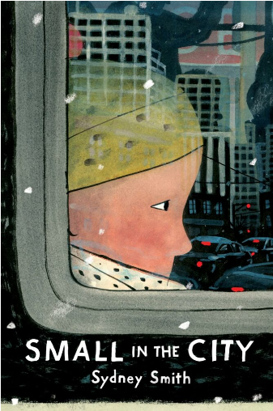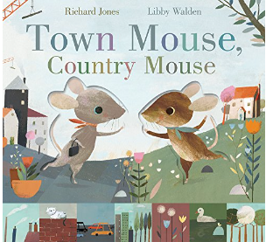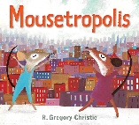 | Year 1  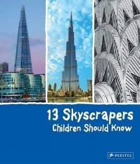  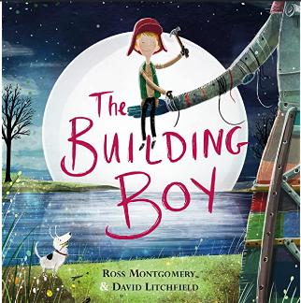  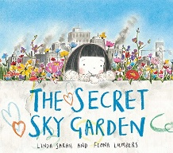  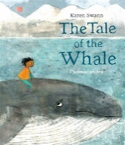 | Year 1  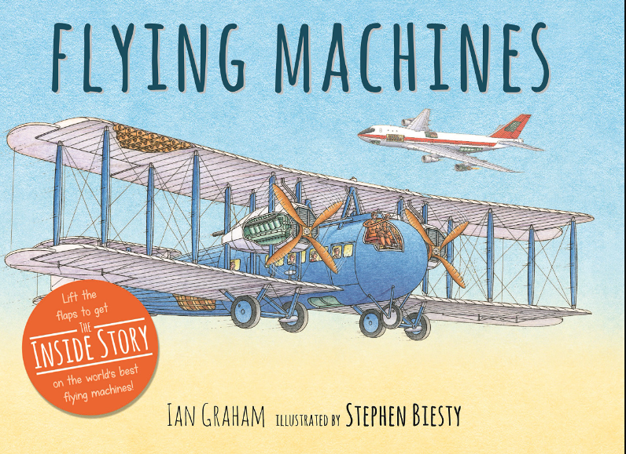  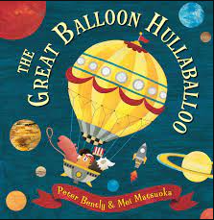  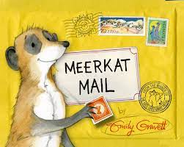  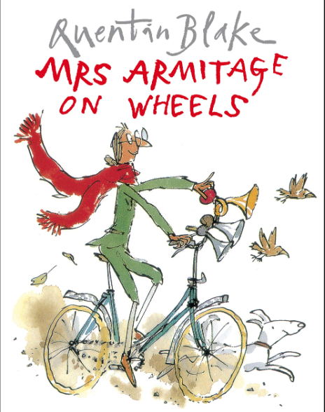 | Year 1  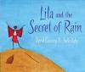  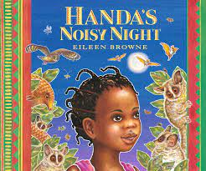  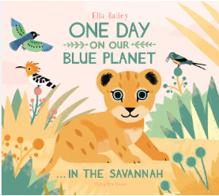  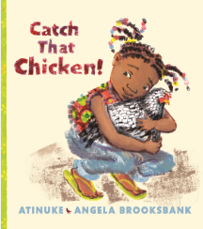 | Year 1  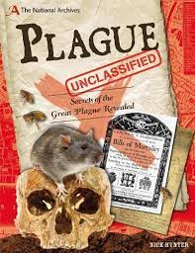  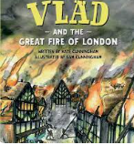  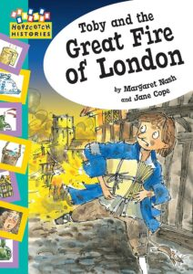  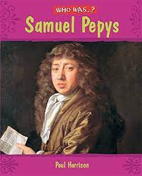 | Year 1  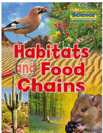  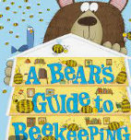  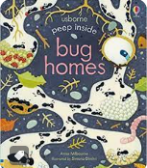  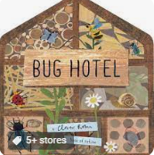  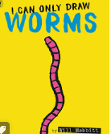
 |  | Year 2  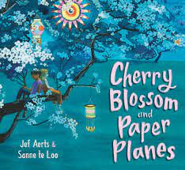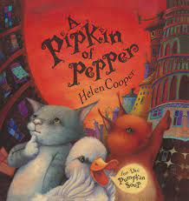  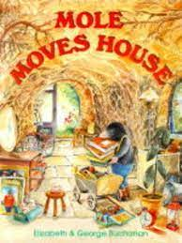 | Year 2  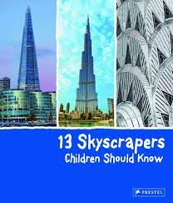  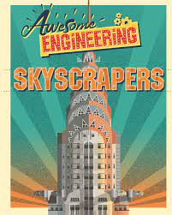  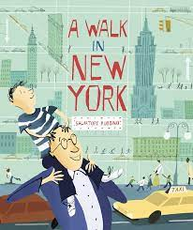  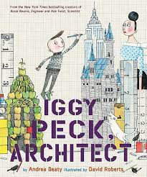 | Year 2  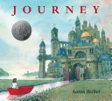  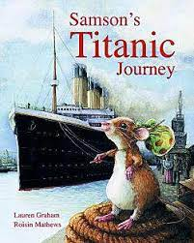  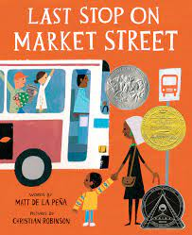  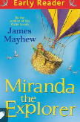 | Year 2  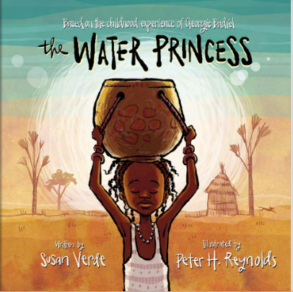  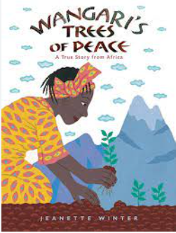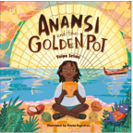  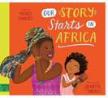 | Year 2  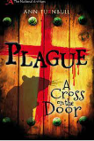  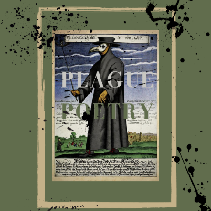  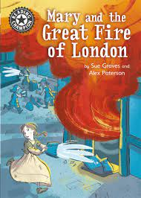  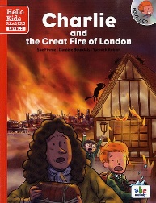 | Year 2  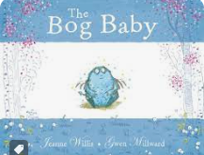  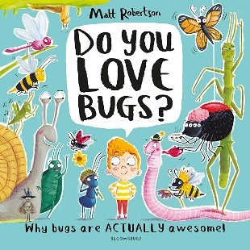  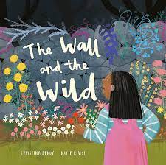  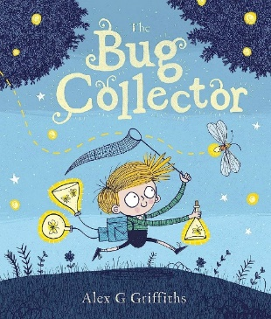
English sequence |  | Narrative-retell a story  Y1  Write simple sentences from a familiar story.  Y2  Use patterns and language from familiar stories in own writing; write complete stories with a simple structure: beginning – middle – end, decide where it is set and use ideas from reading for some incidents and events. | Recount  Y1  Describe incidents from own experience in an audible voice using sequencing words and phrases such as ‘then’, ‘after that’ first, next, after, when.  ; listen to other’s recounts and ask relevant questions.  Write simple first person recounts linked to topics of interest/study or to personal experience, using the language of texts read as models for own writing, maintaining consistency in tense and person.  Y2  Describe incidents from own experience in an audible voice using sequencing words and phrases such as ‘then’, ‘after that’; listen to other’s recounts and ask relevant questions.  Read personal recounts and begin to recognise generic structure, e.g. ordered sequence of events, use of words like first, next, after, when.  Write simple first person recounts linked to topics of interest/study or to personal experience, using the language of texts read as models for own writing, maintaining consistency in tense and person.  Poetry (repeated in Year A and B)  Y1- Firework poem ‘Zim Zam Zoom’  Y2- ‘Firework poem’ The Wright Stuff | Narrative- retell a story, create a resolution and ending  Y1  Use patterns and language from familiar stories in own writing; write complete stories with a simple structure: beginning – middle – end, decide where it is set and use ideas from reading for some incidents and events.  Y2  Imitate familiar stories by borrowing and adapting structures; write complete stories with a sustained, logical sequence of events; use past tense and 3rd person consistently; include setting; create characters, e.g. by adapting ideas about typical story characters; include some dialogue; use phrases drawn from story language to add interest, (e.g.) She couldn’t believe her eyes. | Non chronological report  Y1  Find out about a subject by listening and following text as information books are read, watching a video.  Contribute to a discussion on the subject as information is assembled and the teacher writes the information.  Assemble information on a subject in own experience, (e.g.) food, pets.  Write a simple non-chronological report by writing sentences to describe aspects of the subject.  Y2  After a practical activity or undertaking some research in books or the web, take part in a discussion in another curriculum subject, generalising from repeated occurrences or observations. Distinguish between a description of a single member of a group and the group in general e.g. a particular dog and dogs in general. Read texts containing information in a simple report format, e.g. There are two sorts of x...; They live in x...; the As have x..., but the B’s etc.  Assemble information on another subject and use the text as a template for writing a report on it, using appropriate language to present, and categorise ideas  Poetry  Y1 African Animals  https://www.earlylearninghq.org.uk/latest-resources/african-animals-poem/  Y2  Song of the Animal World (traditional African poem)  Scholastic | Narrative- children create own stories  Y1  Use patterns and language from familiar stories in own writing; write complete stories with a simple structure: beginning – middle – end, decide where it is set and use ideas from reading for some incidents and events.  Y2  Imitate familiar stories by borrowing and adapting structures; write complete stories with a sustained, logical sequence of events; use past tense and 3rd person consistently; include setting; create characters, e.g. by adapting ideas about typical story characters; include some dialogue; use phrases drawn from story language to add interest, (e.g.) she couldn’t believe her eyes. | Persuasion  Y1  Read captions, pictures, posters and adverts that are trying to persuade. Begin to recognise what they are trying to do and some of the ways they do it.  Through games and role play begin to explore what it means to persuade or be persuaded, and what different methods might be effective.  Y2  As part of a wide range of reading, explore simple persuasive texts (posters, adverts, etc.) and begin to understand what they are doing and how.  Evaluate simple persuasive devices (e.g.) Say which posters in a shop or TV adverts would make them want to buy something, and why)  Create simple signs posters and adverts (involving words and/or other modes of communication) to persuade others to do, think or buy something.  Continue to explore persuading and being persuaded in a variety of real life situations through role-play and drama.  Poetry  Y1 Nut tree by Julia Donaldson  What do you do on a nature walk by Kate Williams  Y2 Y2 Mr Magoo’s Amazing Zoo (repeated from Year A Spring 2)
Year 1  Grammar |  | Writing simple sentences with capital letters,  full stops  finger spaces  Nouns and verbs (The dog can run. The frog can hop.) | Capital I for first person pronouns. Adjectives. Noun phrases (The big dog can run. The green frog can hop.) | Present tense. Coordination using ‘and’.  Suffixes ing, ed | Plurals s, es Coordination using ‘but’. | Writing in past tense Coordination using ‘so’.  Suffixes er, est | Capital letters for proper nouns.  Prefix un
Year 2  Grammar |  | Capital letters, full stops, nouns, verbs, adjectives.  (The green frog is jumping down the  road.) | Sentence forms - questions and exclamations Subordinating (  because) and coordinating (and, so, but) conjunctions. | Expanded noun phrases,  past tense (ed)  subordinating (that) /coordinating (and, so, but)  Commas in a list | Expanded noun phrases subordinating (when, if)/coordinating (and, so, but)  Apostrophes for contracted form | Expanded noun phrases subordinating (when, if)/coordinating (and, so, but)  Adverbs-  suffix ly, ful | Expanded noun phrases subordinating (when, if)/coordinating (and, so, but)  Speech marks Prefixes - ment, ness & less.  Sentence form – commands  Apostrophes for the possessive.
Year 1  Handwriting |  | Letter formation check  Order to teach:  L,I,t  t,j,  c,o,a  d,g,q  e – revise d,g  r,n,m  n,m,h  b,k | Order to teach:  p – revise any that need it  v,w  u,y  s,f  x,z  revise and that need it. | Order to teach:  L,I,t  t,j,  c,o,a  d,g,q  e – revise d,g  r,n,m  n,m,h  b,k  include in words. | L,I,t  t,j,  c,o,a  d,g,q  e – revise d,g  r,n,m  n,m,h  b,k  include in words. | Numerals and capital letters. | Capital letters.  Revision of errors.  (Expectation that all upper and lower case letters & numerals are formed correctly by the end of Y1)
Year 2  Handwriting |  | Letter formation check  Revise  L,I,t  t,j,  c,o,a  d,g,q  e – revise d,g  r,n,m  n,m,h  b,k  include in words. | L,I,t  t,j,  c,o,a  d,g,q  e – revise d,g  r,n,m  n,m,h  b,k  include in words. | Capital letters. | Order to teach joins.  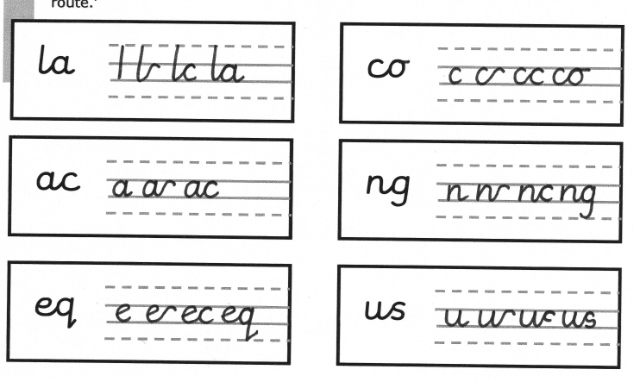  Use the joins within words. | Order to teach joins.  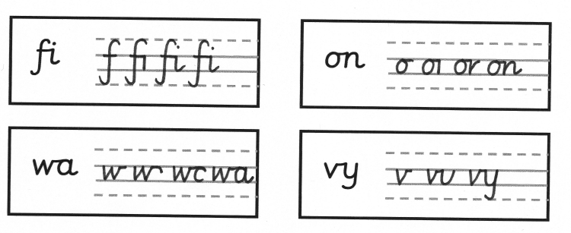  Use the joins within words. | Order to teach joins.  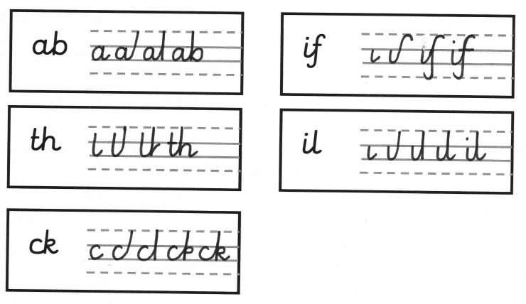  Use the joins within words.
Year One Spelling |  | he, the, do, to, today, of, said, says, are, | were, was, is, his, has, I, you, your, they, be, he | me, she, we, no, go, so, by, my, here, there | where, love, come, some, one, once, ask, friend, school, put | push, pull, full, house, our, door, floor, poor, because, | find, kind, mind, behind, child, children*, wild, climb, most, only,
Year Two Spelling |  | both, old, cold, gold, hold, told, every, everybody, even, great | break, steak, pretty, beautiful, after, fast, last, past, father, class, | grass, pass, plant, path, bath, hour, move, prove, improve, sure, | sugar, eye, could, should, would, who, whole, any, many, clothes | busy, people, water, again, half, money, Mr, Mrs, parents, Christmas | Recap of what is needed
Maths  Year 1 |  | Number: Place Value  (Within 10)  Number: Addition & Subtraction  (Within 10) | Number: Addition & Subtraction  (Within 10)  Geometry: Shape  Number: Place Value  (Within 20) | Number: Addition & Subtraction  (Within 20)  Number: Place Value  (Within 50)  (Multiples of 2,5 & 10 included) | Measurement:  Length & Height  Measurement:  Weight & Volume | Number: Multiplication  & Division  (Reinforce multiples of 2,5,& 10 to be included)  Number:  Fractions  Geometry: Position & Direction | Number: Place  Value (within 100)  Measurement: Money  Measurement:  Time
Maths  Year 2 |  | Number: Place Value  Number: Addition & Subtraction | Number: Addition & Subtraction  Measurement:  Money  Number:  Multiplication &  Division | Number:  Multiplication &  Division  Statistics  Geometry: Properties  Of Shape | Number: Fractions  Measurement:  Length & Height | Measurement:  Time  Measurement: Mass,  Capacity & Temperature | Geometry: Position &  Direction  Problem solving  & efficient  strategies
Science |  | Name different body parts. Senses  Investigating materials- particularly metal  What makes good cutlery | Investigating materials for strength – what materials make a good bridge? | Investigating materials- fabric and plastic with an aim to make a parachute. | Basic needs of animals  including humans  identify and name a variety of common animals that are carnivores, herbivores and omnivores | Investigating materials that are combustible- link to Great Fire of London | Explore difference between things that are living, dead and never been alive.  Identify that most things live in habitats – investigate different habitats and how they provide for the basic needs of different animals, identify and name plants and animals in habitats.  Name common animals, amphibians reptiles, birds and animals.  Identify carnivores, herbivores and omnivores.  - Compare and contrast meadow, pond and field.
Computing  Year one  Year two |  | TCC Y1 – Technology around us (key skills).  Learners will develop their understanding of technology and how it can help them in their everyday lives. They will start to become familiar with the different components of a computer by developing their keyboard and mouse skills. Learners will also consider how to use technology responsibly. | TCC Y1 – Creating media: Digital painting.  Learners will develop their understanding of a range of tools used for digital painting. They then use these tools to create their own digital paintings, while gaining inspiration from a range of artists’ work. The unit concludes with learners considering their preferences when painting with and without the use of digital devices. | TCC Y1 – Creating media: Digital writing.  Learners will develop their understanding of the various aspects of using a computer to create and manipulate text. They will become more familiar with using a keyboard and mouse to enter and remove text. Learners will also consider how to change the look of their text, and will be able to justify their reasoning in making these changes. Finally, learners will consider the differences between using a computer to create text, and writing text on paper. They will be able to explain which method they prefer and explain their reasoning for choosing this. | TCC Y1 – Grouping data  This unit introduces learners to data and information. Labelling, grouping, and searching are important aspects of data and information. Searching is a common operation in many applications, and requires an understanding that to search data, it must have labels. This unit of work focuses on assigning data (images) with different labels in order to demonstrate how computers are able to group and present data.  During this unit, learners will be logging on to the computers, opening their documents, and saving their documents. | SSoW KS1 Unit 4A - Simple Programs: Bee-Bot  In this series of lessons pupils will learn how to use floor robots, e.g. BeeBots in a more structured way. They will learn about algorithms and programs, and create their own simple and extended programs, and use logical thinking to plan out algorithms to solve given problems. | TCC Y1 – Programming animations.  Learners will be introduced to on-screen programming through ScratchJr. Learners will explore the way a project looks by investigating sprites and backgrounds. They will use programming blocks to use, modify, and create programs. Learners will also be introduced to the early stages of program design through the introduction of algorithms.
 |  | TCC Y1 – IT around us.  Learners will develop their understanding of what information technology (IT) is and will begin to identify examples. They will discuss where they have seen IT in school and beyond, in settings such as shops, hospitals, and libraries. Learners will then investigate how IT improves our world, and they will learn about the importance of using IT responsibly. | TCC Y3 – Stop frame animation.  Learners will use a range of techniques to create a stop-frame animation using tablets. Next, they will apply those skills to create a story-based animation. This unit will conclude with learners adding other types of media to their animation, such as music and text. | TCC Y1 – Creating media: Digital writing.  Learners will develop their understanding of the various aspects of using a computer to create and manipulate text. They will become more familiar with using a keyboard and mouse to enter and remove text. Learners will also consider how to change the look of their text, and will be able to justify their reasoning in making these changes. Finally, learners will consider the differences between using a computer to create text, and writing text on paper. They will be able to explain which method they prefer and explain their reasoning for choosing this. | TCC Y3 – Branching databases.  Learners will develop their understanding of what a branching database is and how to create one. They will use yes/no questions to gain an understanding of what attributes are and how to use them to sort groups of objects. Learners will create physical and on-screen branching databases. To conclude the unit, they will create an identification tool using a branching database, which they will test by using it. They will also consider real-world applications for branching databases. | SSoW Unit 4.2 Extending Bee-Bot Programs  In this series of lessons pupils will extend their knowledge of programming floor robots, e.g. Bee-Bots and create more complex programs to draw numbers and create a robot dance. They will learn more about algorithms and programs, and use logical thinking to plan out algorithms to solve given problems. | TCC Y1 – Programming animations.  Learners will be introduced to on-screen programming through ScratchJr. Learners will explore the way a project looks by investigating sprites and backgrounds. They will use programming blocks to use, modify, and create programs. Learners will also be introduced to the early stages of program design through the introduction of algorithms.
Online Safety  YEAR 1 |  | It’s Good To Be Me  Online Safety  https://projectevolve.co.uk/toolkit/resources/strand/privacy-and-security/early-years-7/  - Year 1: Add Online Relationships - discuss how to be kind online and how online actions affect others  https://projectevolve.co.uk/toolkit/resources/content/online-relationships/early-years-7/i-can-explain-why-it-is-important-to-be-considerate-and-kind-to-people-online-and-to-respect-their-choices/?from=strands | Celebrating Differences  Year 1: Add Online Bullying - link to discussions on bullying/being kind  https://projectevolve.co.uk/toolkit/resources/content/online-bullying/early-years-7/i-can-explain-what-bullying-is-how-people-may-bully-others-and-how-bullying-can-make-someone-feel/?from=strands  -Online Safety  https://projectevolve.co.uk/toolkit/resources/strand/privacy-and-security/early-years-7/ | Dreams and Goals | Healthy Me  Online Safety  https://projectevolve.co.uk/toolkit/resources/strand/privacy-and-security/early-years-7/  - Year 1: Add Health, Wellbeing and Lifestyle - discuss balancing online and offline activities  https://projectevolve.co.uk/toolkit/resources/strand/health-well-being-and-lifestyle/early-years-7/ | Relationships  Online Safety  https://projectevolve.co.uk/toolkit/resources/strand/privacy-and-security/early-years-7/  - Year 1: Add Online Relationships - discuss communicating kindly online https://projectevolve.co.uk/toolkit/resources/strand/online-relationships/early-years-7/ | Changing Me  Online safety  https://projectevolve.co.uk/toolkit/resources/strand/privacy-and-security/early-years-7/  - Year 1: Add Self Image and Identity - link body image to reputable online sources  https://projectevolve.co.uk/toolkit/resources/strand/self-image-and-identity/early-years-7/
Online Safety  YEAR 2 |  | It’s Good To Be Me  Online Safety  https://projectevolve.co.uk/toolkit/resources/strand/privacy-and-security/early-years-7/  - Year 2: Add Self Image and Identity - discuss developing positive self-image and that online profiles can be misleading  https://projectevolve.co.uk/toolkit/resources/content/self-image-and-identity/early-years-7/i-can-explain-how-other-people-may-look-and-act-differently-online-and-offline/?from=strands | Celebrating Differences  Online Safety https://projectevolve.co.uk/toolkit/resources/strand/privacy-and-security/early-years-7/  - Year 2: Add Online Bullying - discuss ways people can be unkind online and how to respond  https://projectevolve.co.uk/toolkit/resources/strand/online-relationships/early-years-7/ | Dreams and Goals | Healthy Me  Online Safety  https://projectevolve.co.uk/toolkit/resources/strand/privacy-and-security/early-years-7/  - Year 2: Add Health, Wellbeing and Lifestyle - discuss impacts of too much online time  https://projectevolve.co.uk/toolkit/resources/strand/health-well-being-and-lifestyle/early-years-7/ | Relationships  Online safety  https://projectevolve.co.uk/toolkit/resources/strand/privacy-and-security/early-years-7/  - Year 2: Add Online Relationships - discuss differences between online and offline friendships  https://projectevolve.co.uk/toolkit/resources/strand/online-relationships/early-years-7/ | Changing Me  Online Safety https://projectevolve.co.uk/toolkit/resources/strand/privacy-and-security/early-years-7/  -Year 2: Add Privacy and Security - introduce idea of protecting private information online  https://projectevolve.co.uk/toolkit/resources/strand/self-image-and-identity/early-years-7/
DT |  | Levers and sliders  To create a picture of the city with moving parts | Building a megastructure for strength | Wheels and axels | Food technology  Understanding where food comes from  Skills to prepare and cook food |  | Bird feeders/boxes- wood work
Geography  (Cultural Education) |  | Name, locate and identify characteristics of the four countries and capital cities of the United Kingdom and its surrounding seas  Stocksbridge and Sheffield.  Name some physical and human features.  Use fieldworks to study the geography and the key human and physical features of Stocksbridge.  Devise simple maps | N/A | Locate seven continents and 5 oceans  Use world maps, atlases and globes to identify these. | Place knowledge  ▪ understand geographical similarities and differences through studying the human and  physical geography of a small area of the United Kingdom, and of a small area in a  contrasting non-European country | Use maps of the village to identify places where there is evidence of the plague.  Identify features of the landscapes – hills, valley, village, cottage, church, field, stiles etc  Use simple compass directions to describe the location of features and routes on a map
History (Cultural Education) |  | Changes in Sheffield city within living memory.  Significant person in their own locality. Harry Brierly. | N/A | Significant individuals and events  (Wright brothers, Amy Johnson) |  | Tell the story of the plague arriving in Eyam - is it fiction or non-fiction.  Visit Eyam to look for clues – be plague detectives.  The Great Fire of London
Art & Design  (Cultural Education) |  | Pencil dictionary- line and tone | Colour mixing and sculpture- Andy Goldsworthy 2D and 3D | Colour mixing | African Art using colour mixing and pencil skills | Landscapes (in Eyam) and then bring back and compare to Stocksbridge | Sketching and printing
Music  Sparkyard |  | Y1  Exploring pulse through songs and movement.  Controlling pulse using voices and instruments.  Y2  Performing rhythms and movement to a steady pulse.  Copying and creating rhythmic patterns. | Y1  Exploring the difference between pulse and rhythm.  Copying and creating rhythmic patterns with long and short notes.  Y2  Combining rhythmic patterns with a focus on repeating ostinatos, exploring rhythm through movement and copying rhythmic patterns.  Representing rhythmic patterns by finding and copying rhythms. | Y1  Exploring how sounds can be changed focusing o tempo, describing music and vocal timbre.  Exploring the timbre of instruments and voices.  Y2  Recognising and exploring musical mood.  Choosing sounds to match a character, mood or theme. | Y1  Sequencing sounds to tell stories and create effects.  Copying and creating rhythmic patterns.  Y2  Sequencing and combining sounds to tell stories and create effects.  Creating and performing soundscapes. | Y1  Recognising changes in pitch and copying simple pitch patterns.  Performing simple melodic patterns using voices and pitched instruments.  Y2  Identifying and describing changes in pitch.  Copying pitch patterns alongside imitating and identifying changes in pitch. | Y1  Representing pitch – children will imitate pitch and compose melodies with high and low notes.  Creating music for a performance.  Y2  Creating and notating simple melodies.  Performing simple musical accompaniments and preparing for performance.
PE INDOOR | Y1 | Complete PE:  Gymnastics  Wide, Narrow,  Curled  Introduction to wide,  narrow and curled  Exploring the difference between  wide, narrow and curled  Transitioning between wide,  narrow and curled movements  Linking two movements  together | iMoves  Dance  Construction  Three progressive lessons use the themes of construction, transport and machines.  Aim of lesson: To be able to perform basic movements to music, and to build a simple themed dance focusing on Construction. | Complete PE:  Gymnastics  Body Parts  Introduction to big/small  body parts  Combining big and small with  wide, narrow and curled  Transition between wide narrow  and curled using big and small  body parts  Adding (linking)  movements together | Complete PE  Dance  The Zoo  Exploring expression  Developing our movements,  adding movements together  Responding to a rhythm:  Introducing partner work  Creating an animal sequence motifs  Exploring relationships  within our motifs  OR  iMoves  Countries  And  Eco Warriors | Complete P  Games For  Understanding  Understanding the principles  of attack/defence  Applying attacking/ defending  principles into a game  Consolidate attacking/defending | Complete PE  Health and  Wellbeing  Introduce and explore agility  Introduce and explore balance  Introduce and  explore coordination:  Bouncing, rolling and throwing
PE INDOOR | Y2 | Complete PE:  Gymnastics  Linking  Developing linking  Linking on apparatus  Jump, roll, balance sequences/on  apparatus  Creation of sequences  Completion of sequences and  performance | iMoves  Dance  Construction  Three progressive lessons use the themes of construction, transport and machines.  Aim of lesson: To be able to perform basic movements to music, and to build a simple themed dance focusing on Construction. | Complete PE:  Gymnastics  Pathways  Explore/develop zig-zag  pathways/on apparatus  Explore/develop curved pathways/  on apparatus  Creation of pathway sequences  Completion of pathways  sequences and performance | Complete PE  Dance  Exploring  Responding to stimuli  Developing our motif with  expression and emotion  Applying choreography  in our motifs  Extending our motifs  Sequences, relationships and  Performance  OR  iMoves  Countries  And  Eco Warriors | Complete PE  Games For  Understanding  Attacking/defending as a team  Understanding the transition  between defence and attack  Create and apply attacking/  defensive tactics | Complete PE:  Health and  Wellbeing  Consolidate agility  Consolidate balancing:  Explore balancing on apparatus  Introduce and explore  coordination: Dribbling and kicking
PE OUTDOOR | Y1 | Complete PE:  Locomotion Running Explore running  Apply running into a game  Explore running at different speeds  Running for speed: Acceleration  Explore running in a team  Consolidate running, apply  running into a  competitive game | Complete PE:  Ball Skills Hands 1  Introduce sending  (bouncing) with control  Introduce aiming with accuracy  Introduce power and speed  when sending a ball  Introduce/develop stopping,  combining sending skills  Combine sending  and receiving skills | Complete PE:  Ball Skills Feet  Develop moving the ball  using the feet  Apply dribbling into games  Consolidate dribbling  Explore kicking (passing)  Apply kicking (passing)  to score a point | Complete PE:  Ball Skills Hands 2  Introduce throwing with  accuracy  Apply throwing with accuracy  in a team  Introduce stopping a ball  Develop sending (rolling) skills to  score a point  Consolidate sending and  stopping to win a game | Complete PE:  Locomotion:  Jumping  Recap jumping  Develop jumping  Explore how jumping  affects our bodies  Explore skipping  Apply skipping and  jumping into a game | Complete PE:  Team Building  Introducing teamwork  Develop teamwork  Building trust and  developing communication  Cooperation and communication  Explore simple strategies  Problem solving:  Consolidate teamwork
PE OUTDOOR | Y2 | Complete PE:  Locomotion:  Dodging  Explore dodging  Develop dodging  Apply dodging:  Explore attacking and defending  Apply dodging in teams | Complete PE:  Ball Skills Hands 1  Develop dribbling/passing  and receiving  Combine dribbling, passing and  receiving, keeping possession  Develop dribbling/passing and  receiving to score a point  Combine dribbling, passing and  receiving to score a point | Complete PE:  Ball Skills Feet  Develop dribbling/passing/  receiving, keeping possession  Combine dribbling, passing and  receiving, keeping  possession/to score a point  Apply dribbling, passing and  receiving as a team  to score a point | Complete PE:  Ball Skills Hands 2  Consolidate pupils  application and understanding  of underarm throwing  Applying the underarm and  overarm throw to win a game  Applying the underarm throw to  beat an opponent | Complete PE:  Locomotion:  Jumping  Consolidate jumping  Apply jumping into a game  Linking jumping  Explore jumping combinations  Develop jumping combinations | Complete PE:  Team Building  Introducing teamwork  Develop teamwork  Building trust and  developing communication  Cooperation and communication  Explore simple strategies  Problem solving:  Consolidate teamwork
Active Travel
RE YEAR 1  https://www.natre.org.uk/member-login/  (Spiritual, moral, social & cultural education) |  | 1.2Who do Christians say made the world?  Harvest | 1.7 Who is Jewish and how do they live? (part 1) | 1.1 What do Christians believe God is like? | 1.7 Who is Jewish and how do they live? (part 2) | 1.10 What does it mean to belong to a faith community? (C,J,M) | 1.9 How should we care for the world and for others, and why does it matter? (C,J,NR)
RE YEAR 2  https://www.natre.org.uk/member-login/  (Spiritual, moral, social & cultural education) |  | 1.6 Who is Muslim and how do they live? (part 1) | 1.3 Why does Christmas matter to Christians? | 1.6 Who is Muslim and how do they live? (part 2) | 1.4 What is the ‘good news’ Christians believe Jesus brings? | 1.5 Why does Easter matter to Christians? | 1.8 What makes some places sacred to believers? (C,M)
PHSE including MH & WB.  (Social & Moral Education) |  | New Beginnings  Theme from the book: friendships, other people’s viewpoints, jealous and sharing | Relationships  Anti-bullying week | Good to be Me | Getting on and falling out | Going for goals  Looking after our environment. | Changes
Metacognition |  | Learning a new skill  Rec – Makaton  Y1 – tying shoe laces  Y2 – using chopsticks |  | Growth mindsets – Austin’s butterfly | Growth mindsets – Austin’s butterfly | Integrating Metacognition into the everyday curriculum | Integrating Metacognition into the everyday curriculum

