**School Advice**

**Sessions**

**The School Engagement Team is part of the Family Intervention Service.**

**We work with schools to give families information, advice and support.**

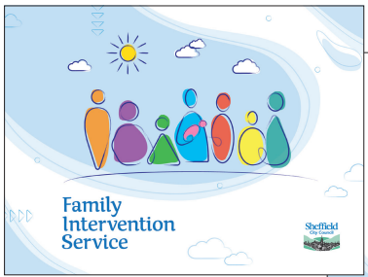]

**You can request a school advice session through your child’s school.**

**Just ask the class teacher, pastoral lead or a member of reception staff.**

Your School Engagement Team Link Worker and school will work together with you to help to address your family’s needs and create happier children and families.

**Do you need support with…?**

* Managing challenging behaviour
* Making your home a more positive place for the whole family
* Improving routines and boundaries
* Support around the under 5’s with their behaviour, development, and school readiness
* Supporting your child’s emotional wellbeing or mental health
* Finding or accessing services to support your family’s needs.