Half Term Fun With
At Stocksbridge Library on
Wednesday 25th October 2.00-4.00pm.

Come and join us for a fun craft session where you will create your own wall hanging using recycled materials and weaving techniques.

Suitable for children 7-12 years of age. Places are limited and must be booked via the library.

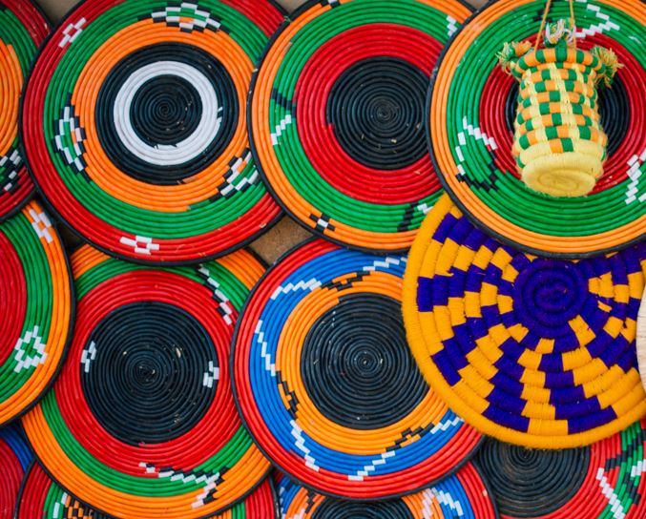

All children attending must be accompanied and supervised by a parent/carer or other responsible adult.

