Stocksbridge Nursery Infant School

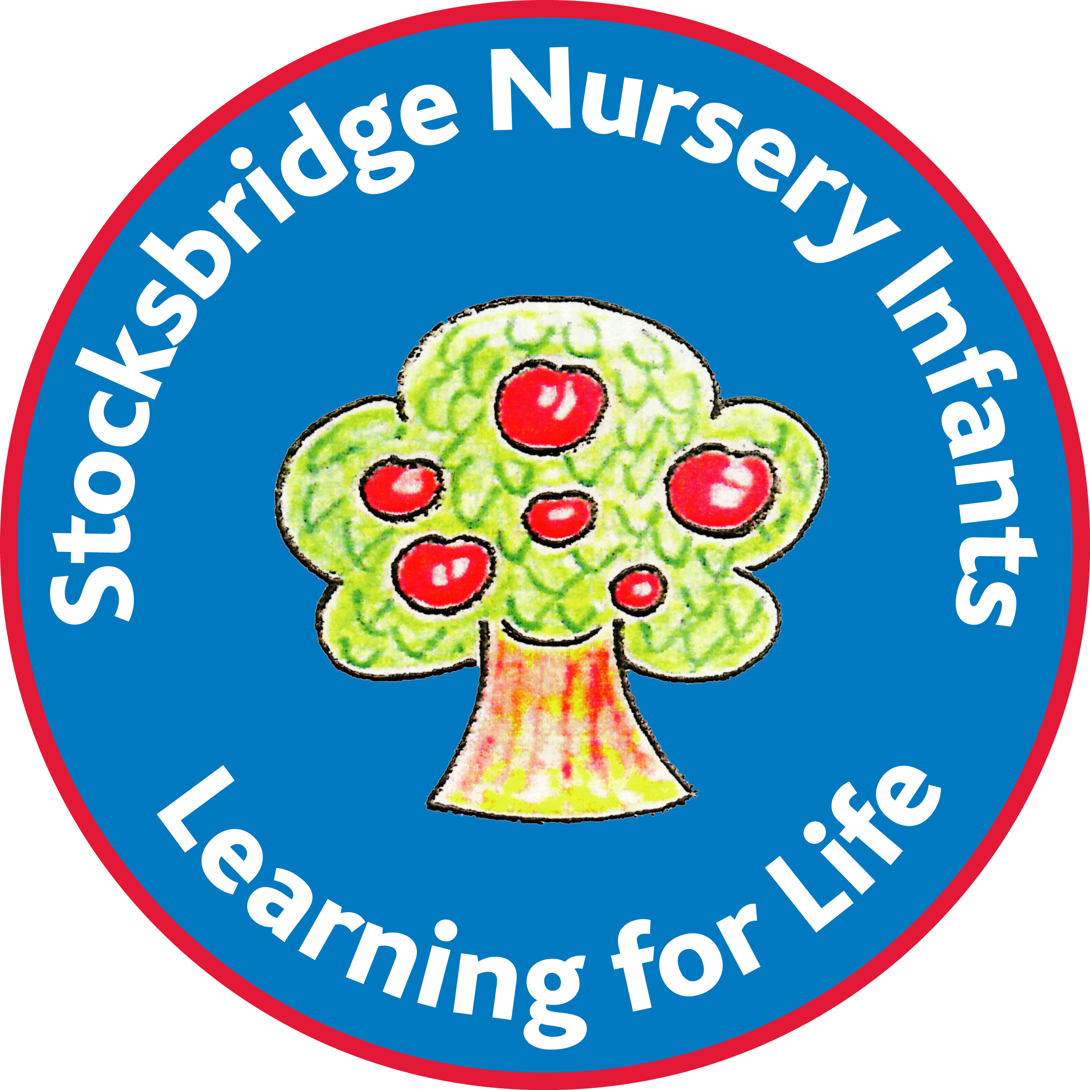

Relationship Sex and Health Education Policy

January 2021
Consultation Scheduled – Summer Term 2024

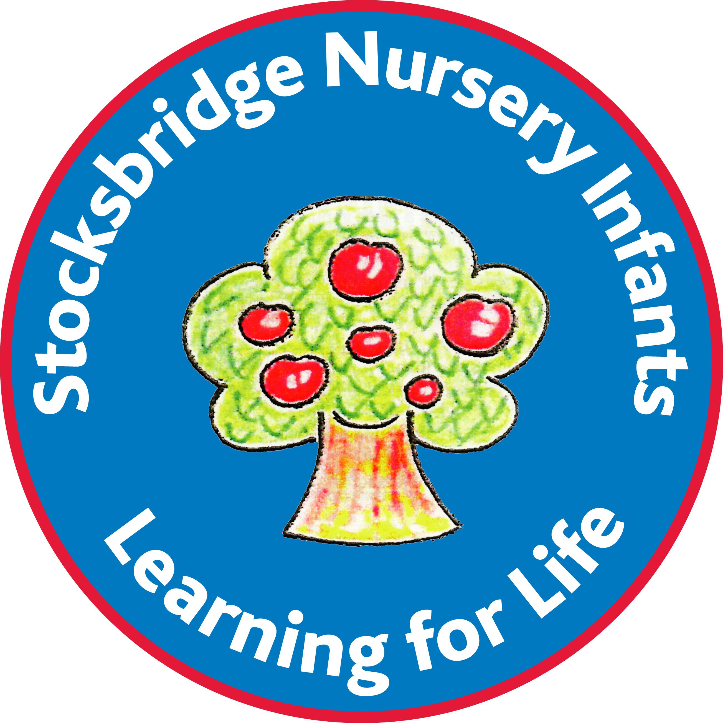
Stocksbridge Nursery Infant School

Relationships, Sex and Health Education (RSHE)

Stocksbridge Nursery Infant School, follow the Sheffield authority guidance on delivering and planning for RSHE. In accordance with this guidance we use recommended resources and session plans.
Sheffield authority have consulted widely over a significant period of time with a full range of community groups. This discussion has culminated in local authority school guidance that is supported by faith groups and other community groups across the city.

At Stocksbridge Nursery Infant school, RSHE is taught through a thematic, topic-based approach. For example, the birth of pets may be linked by younger children to the birth of a baby within their family. Each question arising is dealt with sensitivity and care.

It is a legal requirement that RSHE is taught as part of a school curriculum within a multicultural society, and should encourage pupils to have due regard for moral considerations and the value of family life (The Relationships Education, Relationships and Sex Education and Health Education (England) Regulations 2019, made under sections 34 and 35 of the Children and Social Work Act 2017, make Relationships Education compulsory for all pupils receiving primary education and Relationships and Sex Education (RSE) compulsory for all pupils receiving secondary education).

Aims for all our pupils to:-
- Develop a healthy, respectful and positive self-image.
- Recognise and respond positively to a range of emotions in themselves and
others.
- Be resilient. Learn to accept initial failure or disappointment yet persevere to make changes.
- Be responsible for their actions making informed choices regarding personal, community and wider social issues. In so doing develop their sense of self-worth and self- identity.
- Acquire skills and knowledge enabling them to cope with everyday challenges in their life. For example, managing stress that may come from the breakdown in a significant relationship, in feeling unwell or in a challenge set by their class teacher.
- Develop to their personal potential.
- Demonstrate care for others in the local and wider community.
- Respect others. To understand, tolerate and celebrate differences, and co-operate with others.
- Begin to make sense of the world. To consider their immediate and personal relationships through to extended wider and on line relationships.
- Broaden their horizons and open their minds to possibilities and experiences.
- Develop a sense of belonging as positive and active members of their immediate school community, through to their local and wider British democratic society.
- Know and understand what constitutes a healthy life style, and be aware of safety issues. For example, medication, balanced diet, personal space, privacy, hygiene, sleep and safe use of the internet and social media.
- Make simple active choices to maintain safety, health and wellbeing. For example, in seeking support if they feel unwell or unsafe; offering support if they notice another in distress or discomfort; knowing who they can seek help from; be confident to clearly communicate the support or help they need; to take some healthy foods/ liquids as part of the school day; manage their own hygiene; to engage in both calm and energetic activity through the school day.

The Governors, staff and parent’s Sex Education working group at Stocksbridge Nursery Infant School believe our RSHE programme promotes pupil’s self-esteem, emotional development and resourcefulness, and helps children to form and maintain satisfying, healthy, respectful and safe relationships. This begins a lifelong process of understanding emotions and feelings, acquiring information, developing skills and forming positive beliefs, and attitudes about sex and sexuality in later life (Key stage 2 and beyond). Our RSHE program, therefore supports our pupils to develop the skills and understanding they need to live confident, healthy, respectful and safe independent lives.

RSHE is-
- Delivered and reinforced throughout our curriculum, including science, Personal Social Health Education (PSHE), Physical Education (PE), History, Religious Education (RE), Geography and computing curriculums.
- Set in the context of family life, in a non-stereotyped way; referring to loving, stable relationships between adults and children.
- Correctly pitched with language and images suitable for the age and maturity of our children, using resources commonly used through Sheffield local authority schools.
- Dealt with in a positive and sensitive manner, so as not to cause personal offense or hurt.
- Sensitive to parents/ carers beliefs and views.
- Part of an entitlement of every child in school to access a broad and balanced curriculum. That national curriculum is set out in law (2013)
- Empowering for all pupils regardless of sexuality, gender, ethnicity, cultural beliefs or cultural heritage, faith, physical ability, academic ability or family circumstances. It is empowering for all pupils inclusively, without prejudice, and with respect, in line with our school values and ethos.

Sex Education Objectives
We are that aware that some members of our community may have concerns at the nature of this specific aspect of our curriculum. We therefore will set out below more detail for your knowledge and understanding. We hope that this will alleviate any concerns that you may have.
By the end of Key Stage 1 (year 2) pupils should:-
- Have completed the RSHE programs of study for learning, in particular.
- Understand what biologically makes a boy or a girl.
- Name their body parts, including external genitalia (vulva, vagina, penis and testicles).
- To understand vocabulary of penis, testicle, vagina, vulva, boy, girl, non-binary.
- Discuss the similarities and differences between boys and girls, including ideas that challenge gender stereotypes.
- Understand what ‘private’ means in terms of direct relationships; that they own their body; that they have the right to control who they share private space or information with, including saying no.
- Understand what consent means. To know that they control their personal and private spaces, and information and who they share with; that they have the right to say no and withhold consent; their response should be respected and acted upon accordingly.
- Understand what ‘private’ means specifically in terms of online relationships.
- Understand what ‘fair’ and ‘unfair’ statements are, for example, boys don’t wear pink, girls can’t play football, anyone can have long hair, if you like to play with a ball you can try football.
- Knowing how to express feelings of comfort or discomfort in different situations;

- Have completed the full science programmes of study for learning, in particular:-
- notice that animals, including humans, have offspring which grow into adults
- find out about and describe the basic needs of living things to ensure survival (water, food, getting rid of waste and taking in air). This will encompass both plants and animals, including humans
- Describe the importance for humans of: exercise; sleep, rest and relaxation; eating a balanced diet; how to inform a trusted adult if they don’t feel well; hygiene.
- Be introduced to the basic needs of animals for survival; animals including humans. They should also be introduced to the processes of reproduction and growth in animals. The focus at this stage should help pupils to recognise growth; they should not be expected to understand how reproduction occurs.

Resources used for teaching and learning in sex education through our RSHE program
- Sugar and Snails by Sarah Tsiang - Poem about an elderly relative who helps two children redefine their perceived gender roles.
- The Paper Bag Princess by Robert Munsch - Fairy tale with gender roles reversed
- Dogs Don’t Do Ballet by Anna Kemp - a dog who defies gender expectations to achieve their dreams
- No Means No By Jayneen Sanders – enabling children to understand the question ‘Why is it important that our bodies are our own’?
- Video Consent for kids https://vimeo.com/184545127
- Outside the box- a published whole school resource designed specifically to address and reduce gender stereotypes and sexism and promote equality for all.
- The Growing story by Ruth Krauss and Helen Oxenbury – a little boy is desperate to grow alongside his puppy and some chicks.
- Your body is brilliant by Sigrun Danielsdottir – body respect and how everyone’s body is different. Promoting diversity and kindness.
- I like myself by Karen Beaumont – an exuberant ode to self-esteem that celebrates the joy of liking who you are.

Responsibilities within RSHE:
- It is the responsibility of the Governing Body to ensure that RSHE is taught within the parameters of curriculum guidelines that are the entitlement of every child.
- Governors will ensure that staff and parents are consulted about the content and delivery of the curriculum through a letter and meeting. Children may be consulted through the School Council where it is felt appropriate.
- It is up to the school to make sure that the needs of all pupils are met. This may, for individual pupils, mean teaching by more detailed session plans. The child’s class teacher will work closely with the RSHE lead teacher, SENCo, parents and appropriate external agencies, to ensure that pupils with additional needs have equal access to the Sex Education program, and that their needs are met.
- The headteacher has the responsibility to inform parents that they do not have the right to withdraw their child from science lessons (law 1999). The Sex Education programme is taught directly through the science curriculum (law June 2019).
- The PSHE co-ordinator monitors and evaluates RSHE teaching, learning and curriculum content alongside all other subject leads.
- The PSHE co-ordinator will review and update the RSHE policy, materials, and resources. They will work in conjunction with all members of the school community to ensure efficacy.

Guidelines for Teaching Staff
Teachers are aware that:
- If a topic or theme that is particularly concerned with Sex Education is to be taught, a letter should be sent to parents/ carers prior to the teaching. This will enable parents/ carers to consider their views and feelings before responding to their child’s enquiring questions, following on from lessons.
- Parents / carers must have the opportunity to discuss their concerns at a time that is mutually agreed with themselves and school. A concerned parent/ carer should meet with an appropriate member of staff. This may include the safeguarding team where a parent/ carer has personal matters to discuss.
- The School Nurse/ Health Authority can provide guidelines and assistance in teaching this aspect of RSHE.
- The Governing Body has full confidence in the staff of the school, and believes that the best interests of the pupils and their parents / carers will be served by the sensitive consideration of all matters in relation to human sexuality.
- The school follows Local Authority Safe-Guarding guidelines and policies, relating to suspected child abuse and / or harm.
- This policy is specifically linked to PSHE guidance, also computing, RE, history, PE and Science programmes of study.
- This policy is linked to our school policies on behaviour, equal opportunities, teaching and learning, anti-bullying and special educational needs and disabilities (SEND) and Inclusion. https://www.stocksbridgenurseryinfants.co.uk/policies/
- Where a child is visibly uncomfortable and/or upset within a lesson, alternative arrangements will be sensitively made and followed up with parents/ carers.
- Where children ask for further information, which goes beyond our teaching guidelines, staff will discuss this with parents/carers. In conversation both parties will agree an appropriate plan of action and way forward, before responding to the child.
- RSHE and all our other national curriculum subjects are designed to ensure that pupils are taught the knowledge and life skills required to stay safe and develop healthy, respectful and supportive relationships throughout their life time. In particular, in dealing with the challenges of growing up in an online world.

Confidentiality
All staff should be clear about the boundaries of their legal and professional roles and responsibilities. They should be familiar with the procedures set out in DfE 2019 ‘Keeping Children Safe in Education’ as stated in regular Safeguarding Training.
Teachers cannot offer or guarantee absolute confidentiality.

Right of Withdrawal.
Under the curriculum act of June 2020, parents/carers do not have the right to withdraw their child from any lesson that is planned under national curriculum programs of study guidance.
Any parent wishing to discuss this or any aspect of the curriculum in more detail is advised to contact the class teacher initially for more information.

Our actions and decisions are led by Sheffield Authority guidance.

Stocksbridge Nursery Infant School Policies

All our school policies are published on our website https://www.stocksbridgenurseryinfants.co.uk/

SEND Policy:
https://www.stocksbridgenurseryinfants.co.uk/wp-content/uploads/2020/06/SEND-policy-June-2020.pdf
Positive Behaviour Policy:
https://www.stocksbridgenurseryinfants.co.uk/wp-content/uploads/2019/12/Positive-Behaviour-Policy-2019.pdf

Reviewed January 2021 – Alison Priest

