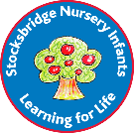
Stocksbridge Nursery Infant school
Key Concepts

Science
Classification
- Bringing order to scientific knowledge.
Changes
- Changing from one material/state to another
Growth
- The process of increasing in size

Communicating scientifically
- Ask simple questions.
- Observe closely, using simple equipment.
Use observations and ideas to suggest answers to questions.

