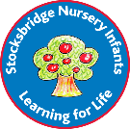

**Stocksbridge Nursery Infant school**

**Key Concepts**

**Art**

Develop ideas

* Respond to ideas and starting points
* Explore ideas and different methods and materials.

Master techniques (paint, drawing, sculpture, printing, textiles)

* Use a range of materials and techniques to represent ideas

Take inspiration from artists

* Describe the work of artists and designers.
* Use some of the ideas of artists studied to create pieces

Communicating artistically

Explain and evaluate art work using subject specific vocabulary